

Department of Computer and Information Sciences
Networks and Cyber Security BSc (Hons)
Academic Year 2025–2026
KV6013: Individual Computing Project
AutoML-Based Anomaly Detection for Cybersecurity Threats in Network Traffic

Supervisor: Amritpal Singh
Student: Mohammad Sohaib
Student ID: 23017751
Submission Date: May 2026
Word Count:

Acknowledgment
I would like to express my sincere gratitude to my project supervisor, Amritpal Singh, for his guidance, support, and valuable feedback throughout this study. I also extend my thanks to my second marker, Biju Issac, for his helpful advice and recommendations, which contributed to the development of this project.
I am grateful to the academic staff for providing the knowledge and foundation that supported this work. Finally, I would like to thank my family and friends for their encouragement and support throughout this journey.

Abstract
The increasing complexity and volume of network traffic have made traditional intrusion detection systems less effective in identifying evolving and previously unseen cyber threats. This study proposes a feature-centric Automated Machine Learning (AutoML) framework for network anomaly detection, aimed at improving detection performance while reducing manual intervention in feature engineering and model selection.
The proposed approach integrates data preprocessing, feature engineering, representation learning, feature selection, and automated model optimisation within a unified pipeline. Multiple feature representation techniques, including Principal Component Analysis (PCA), Autoencoders (AE), and Variational Autoencoders (VAE) were evaluated alongside feature selection methods based on mutual information and checkpoint-based model elimination (CBME). The H2O AutoML framework was used to automate model selection and hyperparameter tuning.
Experiments were conducted on the UNSW-NB15 and NSL-KDD benchmark datasets. The results demonstrate that the combination of mutual information and CBME achieved the best overall performance, with an AUC of 0.9846, F1-score of 0.9365, and a low false positive rate of 0.0494. In addition, the proposed system achieved high inference throughput and low estimated energy consumption, indicating its suitability for practical deployment.
Overall, the study demonstrates that integrating automated feature optimisation with AutoML significantly enhances anomaly detection performance while maintaining computational efficiency, providing a scalable solution for modern network security challenges.

Table of Contents
Acknowledgment 2
Abstract 3
1. Introduction 6
1.1 Background 6
1.2 Anomaly Detection in Network Security 6
1.3 Machine Learning and Unsupervised Approaches 6
1.4 AutoML for Network Anomaly Detection 7
1.5 Problem Statement 7
1.6 Aim and Objectives 7
1.7 Research Questions 8
1.8 Contribution of the Study 8
2. Research and Planning 10
2.1 Research Context and Problem Overview 10
2.2 Literature review 10
2.2.1 Network and Network traffic context 10
2.2.2 Network Anomaly Detection 11
2.2.3 Machine Learning Approaches for Network Anomaly Detection 12
2.2.4 Supervised, Unsupervised and Representation Learning 13
2.2.5 Feature Engineering and Feature Selection in IDS 14
2.2.6 AutoML and Ensemble learning for Intrusion Detection 15
2.2.7 Benchmark Dataset for Network Traffic Anomaly Detection 16
2.2.8 Summary of Key Literature 17
2.2.9 Literature Summary and Research Gap 18
2.3 Approach selection and justification 19
2.4 Tools and technologies 20
3. Methodology and Implementation 21
3.1 Dataset and Experimental Design 21
3.2 Data Preprocessing and Feature Engineering 22
3.3 Representation Learning 22
3.4 Feature Selection and Optimisation 23
3.5 AutoML Model Training 24
3.6 Model Evaluation Metrics 25
3.7 Deployment Demonstration 26
3.8 Challenges and Limitations 26
4. Results and Discussion 27
4.1 Experimental Setup 27
4.2 Feature Representation and Performance Comparison 28
4.3 AutoML Model Leaderboard 29
4.4 ROC and Precision-Recall Curves 30
4.5 Confusion Matrix 32
4.6 SHAP Feature Importance 33
4.7 Energy and Latency Analysis 34
4.8 Final Result Summary 35
4.9 Comparison with Existing Studies 35
4.10 Research Questions Evaluation 36
4.11 Critical Reflection 37
5. Conclusion and Future work 38
5.1 Summary of Findings 38
5.2 Contributions of the Study 39
5.3 Limitations of the Study 40
5.4 Future Work 41
References 42
Appendix 45
Appendix A – AutoML Configuration and Model Details 45
Appendix B – Additional Results and Supporting Figures 46
Appendix C – Dataset Features Summary 47

Introduction

Background
In recent years, cybercrime has grown significantly, posing serious threats to organisations and network infrastructures worldwide. According to Morgan (2020), global cybercrime damages are expected to reach approximately $10.5 trillion annually by 2025, highlighting the scale and impact of cyber threats. Modern cyberattacks are increasingly sophisticated, including zero-day and previously unseen attacks that cannot be effectively detected using traditional signature-based intrusion detection systems (Sommer & Paxson, 2010).
At the same time, the rapid growth in network traffic volume, complexity, and diversity has made traditional detection approaches less effective. Organisations increasingly rely on networked systems for communication and critical services, making them prime targets for cyberattacks. These limitations highlight the need for intelligent, adaptive, and data-driven approaches capable of identifying malicious activity within network traffic (Rookard & Khojandi, 2025).
To monitor the network traffic and detect malicious behaviour, Intrusion detection systems (IDS) are commonly deployed to monitor network traffic and identify potential security risks. Traditional intrusion detection systems are often signature based and relying on predefined patterns of known attacks. While such systems are effective against previously observed threats, they struggle to detect unusual, evolving or zero-day attacks that do not match existing signatures.

Anomaly Detection in Network Security
To address these limitations, anomaly-based intrusion detection has gained significant attention in both academic research and practical security applications. These systems model normal network behaviour and detect deviations that may indicate malicious activity. This approach is particularly well suited to modern network environments, where attack techniques continuously evolve and may not match know signatures. However, anomaly-based system often suffer from high false positive rates and depends heavily on effective feature representation. These challenges highlights the need for more robust and adaptive data-driven detection mechanisms capable of accurately analysing complex network traffic patterns. (Gracia-Teodoro et al., 2009)

Machine Learning and Unsupervised Approaches
Machine learning (ML) techniques have emerged as a powerful alternative to traditional detection methods, enabling systems to learn patterns from large-scale network traffic data. ML-based systems can identify both known and previously unseen threats, making them more adaptive in dynamic environments.
Despite these advantages, ML-based approaches often require extensive manual processes, including feature engineering, feature selection, and model tuning. These requirements increase complexity and reduce scalability, particularly when dealing with high-dimensional datasets. Additionally, performance may degrade in dynamic environments, leading to increased false positive rates (Gyimah, et al., 2025).
In many real-world scenarios, labelled data for new attacks is limited. As a result, unsupervised and representation learning techniques have gained attention, as they can learn patterns without explicit labels. Methods such as Principal Component Analysis (PCA) and autoencoder-based approaches are widely used to capture underlying data structures and improve detection performance (Rookard & Khojandi, 2025).

AutoML for Network Anomaly Detection
To further address the limitations of traditional machine learning approaches, Automated Machine Learning (AutoML) has emerged as a powerful alternative. AutoML frameworks aim to automate key stages of the machine learning pipeline, including data preprocessing, feature selection, model training, and performance evaluation. By reducing manual intervention, AutoML can improve detection performance, reduce false positives, and optimise model development efficiency. Therefore, AutoML-based approaches are particularly well suited for anomaly detection in dynamic and evolving network environments, where adaptability and scalability are critical (Gyimah, et al., 2025), (Baratchi, et al., 2024)

Problem Statement
Despite advancements in intrusion detection systems, identifying cyber threats in modern network traffic remains challenging. Traditional and machine learning-based approaches often rely on manual feature engineering and model tuning, which are impractical for large-scale and high-dimensional datasets.
Furthermore, many anomaly detection systems suffer from high false positive rates, reducing their effectiveness in real-world environment. The dynamic nature of cyberattacks and continuous changes in network traffic behaviour further limit the ability of static models to generalise across different scenarios.
Although machine learning has improved detection capabilities, performance remains highly dependent on feature representation and optimisation strategies. Manual feature selection and parameter tuning introduce potential bias, reduce reproducibility, and require significant domain expertise.
Therefore, there is a need for an automated and scalable approach that can optimise feature representation while improving detection accuracy and reducing false positives. This study addresses this challenge by proposing a feature-centric AutoML framework that integrates feature engineering, representation learning, and model optimisation within a unified pipeline.

Aim and Objectives
Building on the limitations of traditional intrusion detection and machine learning–based anomaly detection systems, this study aims to investigate the use of feature centric automated machine learning techniques to improve anomaly detection performance in network traffic. Particular focus is placed on feature representation and selection, as ineffective or redundant features are a key factor contributing to high false positive rates and reduced detection accuracy.
The primary aim of this project is to design and evaluate a feature-centric AutoML system that automatically generates, optimises, and selects effective feature representations to enhance anomaly detection performance using the UNSW-NB15 dataset.
To achieve this aim, the following objectives are defined:
- To download and preprocess the UNSW-NB15 dataset for anomaly detection.
- To apply feature transformation techniques, including scaling, encoding, and non-linear transformations.
- To generate latent features representation using PCA, Autoencoders, and Variational Autoencoders (VAEs).
- To compute feature importance using mutual information, SHAP, and permutation importance.
- To reduce feature redundancy through correlation analysis.
- To apply checkpoint-based model elimination (CBME) for feature optimisation.
- To train and evaluate machine learning models using the H2O AutoML framework.
- To assess model performance using evaluation metrics including Precision, Recall, F1-score, ROC-AUC, and FPR.
- To develop a reusable AutoML pipeline for anomaly detection.

Research Questions
Based on the identified challenges, this study is guided by the following research questions:
- How can a feature-focused AutoML system be designed to automatically generate and select the effective feature representations for improving anomaly detection performance using the UNSW-NB15 network security dataset?
- What impact do automated feature engineering and representation learning techniques have on anomaly detection accuracy and overall model performance?
- How can feature selection strategies and feedback-based model reducr false positives and improving detection reliability in network anomaly detection systems?
These research questions aim to evaluate the effectiveness of combining automated feature engineering, representation learning, and AutoML-based optimisation for anomaly detection in dynamic network environments.

Contribution of the Study
This study makes the following contributions to the field of network anomaly detection:
- The design and implementation of a feature-centric AutoML framework that integrates preprocessing, representation learning, feature selection, and automated model optimisation within a unified pipeline.
- A systematic comparison of feature representation techniques, including Principal Component Analysis (PCA), Autoencoders (AE), and Variational Autoencoders (VAE), within an anomaly detection context.
- The application of checkpoint-based model elimination (CBME) as a performance-driven feature optimisation strategy to improve detection accuracy while reducing feature dimensionality.
- The incorporation of feedback-based model refinement to enhance detection reliability and reduce false positive rates.
- Cross-dataset evaluation using UNSW-NB15 and NSL-KDD, demonstrating the robustness and generalisability of the proposed framework.
- The evaluation of both detection performance and computational efficiency, including inference speed and estimated energy consumption, supporting practical deployment considerations.
- The development of a reusable and automated anomaly detection pipeline suitable for dynamic network environments.

Research and Planning

Research Context and Problem Overview
The increasing reliance on networked systems across modern organisations has significantly expanded the attack surface for cyber threats. As network traffic continues to grow in scale, complexity, and diversity, detecting malicious behaviour within such environments has become increasingly challenging. Traditional intrusion detection systems, particularly signature-based approaches, are limited in their ability to identify evolving and previously unseen attacks.
Although machine learning techniques have improved anomaly detection capabilities, their effectiveness remains highly dependent on feature engineering, data preprocessing, and model selection. These processes often require extensive manual intervention, domain expertise, and iterative tuning, which can reduce scalability and limit adaptability in dynamic network environments. Furthermore, many existing systems struggle with high false positive rates and limited generalisation across different datasets.
These limitations highlight the need for more automated and robust approaches capable of systematically optimising feature representations and model configurations. Integrating automated feature engineering, representation learning, and model optimisation within a unified framework presents a promising direction for improving anomaly detection performance.
Therefore, the following literature review examines existing research in network anomaly detection, machine learning approaches, feature optimisation techniques, and AutoML frameworks to identify current challenges and research gaps.

Literature review
This section reviews existing research related to network anomaly detection and machine learning-based intrusion detection systems. It introduces the context of network traffic analysis outlines anomaly detection and machine learning approaches used in cybersecurity. and examines representation learning, feature optimisation, AutoML frameworks, and benchmark datasets before identifying the research gap addressed by this study.

Network and Network traffic context
Computer networks form the foundation of modern digital infrastructure, enabling communication between distributed systems, devices, and applications. A computer network can be defined as a collection of interconnected computing devices that exchange data using established communication protocols (Tanenbaum & Wetherall, 2011). Networks support a wide range of services, including cloud computing, financial transactions, healthcare systems, industrial control systems, and IoT environments. As organisations increasingly rely on digital connectivity, network reliability and security have become critical operational requirements.
The scale and complexity of network environments have expanded significantly over the past decade. The rapid growth of Internet-connected devices, mobile systems, and cloud-based services has led to substantial increase in network traffic volume and heterogeneity. (Zuech, Khoshgoftarr, & Wald, 2015) highlight that modern networks generate large volumes of heterogeneous data, characterised by high velocity and high dimensionality. This growth increases management complexity and expands the exposure of systems to potential threats.
Network traffic consists of structured and semi-structured data flows transmitted between endpoints. It can be analysed at different levels, including packet-level inspection and flow-level summarisation. Flow-based features such as byte counts, packet rates, time-to-live (TTL) values, and protocol information are commonly used to characterise communication behaviour. These features provide insights into system activity patterns and are widely used in network monitoring and traffic analysis (Moustafa & Slay, 2015).
Because network traffic reflects real-time operational behaviour, it often contains sensitive information related to user activities and system interactions. Unauthorised manipulation, interception, or misuse of network traffic can compromise confidentiality and disrupt system availability. As a result, monitoring and analysing network traffic has become an essential component of cybersecurity strategy.
The increasing scale, diversity, and sensitivity of network communication highlight the importance of developing advanced methods for analysing traffic behaviour. Understanding the structural and statistical properties of network data provides the foundation for building robust security and monitoring systems, as explored in the following sections.

Network Anomaly Detection
Network anomaly detection refers to techniques used to identify deviations from established patterns of normal network behaviour. Unlike signature-based intrusion detection systems, which rely on predefined attack signatures, anomaly-based systems aim to construct a behavioural model of legitimate traffic and flag activities that significantly diverge from this baseline (García-Teodoro et al., 2009). This makes anomaly detection particularly effective for identifying previously unseen or zero-day attacks that cannot be captured using static rule sets.
According to García-Teodoro et al. (2009), anomaly detection approaches can be broadly categorised into statistical, knowledge-based, and machine learning-based methods. Statistical techniques model normal behaviour using probabilistic distributions, while knowledge-based methods rely on expert-defined rules. In contrast, learning-based approaches infer patterns directly from data. Despite these differences, all approaches share the assumption that malicious activity appears as a deviation from normal behaviour.
Despite its advantages, anomaly detection presents significant operational challenges, particularly high false positive rates. Network traffic is inherently dynamic and context-dependent, and legitimate but uncommon behaviour may be incorrectly classified as malicious. This reduces analyst trust and increases alert fatigue, limiting real-world deployment effectiveness (Buczak & Guven, 2016). The variability of traffic patterns across different environments further complicates the construction of robust behavioural models.
Another challenge lies in accurately representing normal behaviour. Network environments evolve continuously due to changes in user behaviour, software updates, infrastructure modifications, and emerging communication protocols. As a result, models trained on historical data may struggle to generalise to new contexts, leading to performance degradation over time. García-Teodoro et al. (2009) emphasise the need to balance sensitivity to attacks with robustness to legitimate behavioural variation.
Furthermore, detection performance is highly dependent feature representation. Inadequate or redundant features can significantly affect classification reliability (Buczak & Guven, 2016). Consequently, feature selection and representation learning have become critical components in improving anomaly detection systems.
Overall, although anomaly-based detection is effective for identifying novel threats, its practical success depends on robust behavioural modelling, appropriate feature representation, and reduced false alarm rates. These challenges have driven the adoption of data-driven machine learning techniques in modern intrusion detection systems.

Machine Learning Approaches for Network Anomaly Detection
Machine learning has become a fundamental component of modern network anomaly detection systems due to its ability to model complex, high-dimensional traffic behaviour. Unlike rule-based systems, machine learning algorithms learn patterns directly from data, enabling adaptive identification of malicious activities. As outlined by (Buczak & Guven, 2016), machine learning techniques used in intrusion detection systems (IDS) can be categorised into supervised, unsupervised, and semi-supervised approaches depending on the availability of labelled data.
Supervised learning models require labelled datasets containing both normal and attack traffic. Algorithms such as Support Vector Machines (SVM), Decision Trees, Random Forests, and k-Nearest Neighbours (k-NN) have demonstrated strong detection performance on benchmark datasets (Buczak & Guven, 2016). These models can capture non-linear relationships and achieve high accuracy when sufficient labelled data is available. However, supervised approaches depend on labelled datasets and may struggle to detect novel attack patterns which are not present in the training data.
Unsupervised learning methods address this limitation by modelling normal traffic behaviour without requiring labelled attack data. According to (Chandola, Banerjee, & Kumar, 2009), anomaly detection in unsupervised settings identifies instances that deviate significantly from learned patterns. Techniques such as clustering, density-based modelling, and reconstruction-based approaches are commonly used. Recent work by (Rookard & Khojandi, 2025) highlights the application of unsupervised learning in dynamic network environments where labelled data may be limited.
In recent years, deep learning has further advanced anomaly detection research. Neural network architectures such as Deep Neural Networks (DNN), Convolutional Neural Networks (CNN), Recurrent Neural Networks (RNN), and Autoencoders have been widely explored for their ability to learn hierarchical feature representations. These models capture complex feature interactions and temporal dependencies that traditional models may overlook (Buczak & Guven, 2016). Studies such as Almuhanna and Dardouri (2025) report improved performance using hybrid deep learning frameworks that combine traditional machine learning with neural network-based feature extraction.
Despite these advances, machine learning-based intrusion detection systems remain sensitive to preprocessing, feature selection, and hyperparameter configuration. Performance can vary depending on how features are constructed and models are tuned (Buczak & Guven, 2016). Pai et al. (2025) emphasise that anomaly detection models must account for evolving traffic patterns to maintain reliability. Deep learning models also require significant computational resources and careful design.
Moreover, intrusion detection operates in an open-world environment where traffic distributions and attacker behaviour continuously change (Sommer & Paxson, 2010). Models trained on static datasets may therefore degrade when deployed in real networks. These limitations highlight the dependency of performance on feature engineering, parameter tuning, and model design.
Consequently, there is increasing interest in automated optimisation frameworks capable of selecting features, tuning hyperparameters, and identifying robust models. Automated machine learning (AutoML) approaches aim to address these challenges by reducing manual intervention while improving generalisation and reproducibility. For example, (Yang & Shami, 2023) propose an AutoML-based intrusion detection framework that automates preprocessing, feature engineering, model selection, and hyperparameter optimisation. Although primarily evaluated in supervised settings, such approaches demonstrate the shift towards more autonomous detection systems.
Although machine learning provides powerful modelling capabilities, its effectiveness remains highly dependent on feature representation. This has motivated further research into representation learning techniques capable of extracting meaningful feature structures from network data.

Supervised, Unsupervised and Representation Learning
Machine learning approaches for network anomaly detection can be categorised into supervised, unsupervised, and semi-supervised paradigms. These approaches differ in how models are trained and how anomalies are identified within network traffic data.
Supervised learning relies on labelled datasets containing both normal and malicious traffic. Models are trained to classify instances based on known attack categories. Algorithms such as Support Vector Machines, Random Forests, and Neural Networks have demonstrated strong performance when sufficient labelled data is available (Buczak & Guven, 2016). However, obtaining labelled data is costly and time-consuming, and supervised models may struggle to detect previously unseen attacks.
Unsupervised learning addresses this limitation by modelling normal network behaviour without requiring labelled attack data. In this paradigm, anomalies are detected as deviations from learned patterns. (Chandola, Banerjee, & Kumar, 2009) explain that unsupervised detection is particularly useful in domains where malicious behaviour is rare or evolving. Clustering, density-based techniques, and reconstruction-based methods are commonly applied. However, distinguishing between rare legitimate behaviour and malicious activity remains challenging, which may increase false positive rates.
Semi-supervised learning represents an intermediate approach, where models are trained primarily on normal traffic and detect deviations as anomalies. This approach is suitable for intrusion detection, where normal behaviour is more consistently observed than attack behaviour. Reconstruction-based neural network models, particularly autoencoders, are commonly used in this setting.
Representation learning has emerged as an important advancement within these paradigms. Traditional methods rely on manually engineered features derived from packet statistics or flow-level summaries. Representation learning aims to automatically learn meaningful feature representations directly from data. (Bengio, Courville, & Vincent, 2013) describe it as the process of discovering feature hierarchies that improve model performance and generalisation.
Autoencoders play a central role in representation learning for anomaly detection. These models reconstruct input data through a compressed latent representation, enabling the learning of lower-dimensional embeddings of network traffic. This allows the capture of complex non-linear relationships that may not be identified using linear methods. Variational Autoencoders (VAE) extend this approach by introducing probabilistic latent variables, enabling more structured representations. Recent research shows that latent representations can improve robustness and reduce reliance on manual feature engineering (Rookard & Khojandi, 2025).
Despite these advantages, representation learning introduces additional complexity. Model architecture design, latent dimension selection, and optimisation strategies significantly influence performance. Deep models also require substantial computational resources and careful regularisation to avoid overfitting.
The increasing reliance on learned feature representations highlights the shift from manual feature engineering towards automated representation extraction. This transition motivates further investigation into feature optimisation and automated model selection mechanisms.

Feature Engineering and Feature Selection in IDS
Feature engineering plays a critical role in the effectiveness of machine learning-based intrusion detection systems. Network traffic data is high-dimensional and heterogeneous, often containing numerical, categorical, and temporal features derived from packet-level and flow-level statistics. The quality and representation of these features significantly influence detection performance, generalisation, and computational efficiency.
(Buczak & Guven, 2016) emphasise that detection accuracy is highly dependent on feature selection and preprocessing decisions. Redundant, irrelevant, or highly correlated features may degrade performance, increase model complexity, and introduce overfitting. High-dimensional feature spaces can also lead to the “curse of dimensionality,” where algorithms struggle to distinguish between normal and malicious traffic.
Feature engineering strategies in anomaly detection typically fall into two categories: manual feature extraction and automated feature learning. Manual approaches involve selecting statistical traffic attributes such as packet counts, byte ratios, protocol information, and time-based features based on domain knowledge. While effective in structured datasets, manual feature engineering is time-consuming and may not generalise across different environments.
Feature selection techniques aim to reduce dimensionality by identifying the most informative features. Methods such as filter-based, wrapper, and embedded techniques are widely used (Chandola, Banerjee, & Kumar, 2009). Filter-based methods, including Mutual Information and correlation analysis, evaluate feature relevance independently of the model, improving efficiency and reducing noise.
Dimensionality reduction provides an alternative approach by transforming the feature space into a lower-dimensional representation. Principal Component Analysis (PCA) is widely used, projecting data onto orthogonal components that capture maximum variance while reducing redundancy (Zuech, Khoshgoftarr, & Wald, 2015).
Beyond linear methods, representation learning techniques such as autoencoders provide non-linear dimensionality reduction by learning latent embeddings of network traffic. (Bengio, Courville, & Vincent, 2013) note that such representations can capture complex feature interactions that manual methods may overlook. These representations are often used to improve classification robustness and reduce dependence on handcrafted features.
Despite these advances, feature optimisation remains complex and often manual. Selecting thresholds, determining optimal dimensionality, and evaluating feature subsets require domain expertise and iterative experimentation. Feature importance may also vary across datasets, limiting transferability.
The dependency of detection performance on feature representation highlights the need for systematic and automated optimisation strategies. Reducing manual intervention is essential for developing scalable anomaly detection frameworks, motivating the integration of automated optimisation methods.

AutoML and Ensemble learning for Intrusion Detection
Automated Machine Learning (AutoML) has emerged as an important advancement in the development of machine learning systems, aiming to automate key stages of the pipeline, including data preprocessing, feature engineering, model selection, and hyperparameter optimisation (Mitra Baratchi, et al., 2024). Traditional machine learning workflows in intrusion detection systems (IDS) require substantial manual configuration and expert knowledge, particularly in selecting model architectures and tuning hyperparameters. This dependency increases development complexity and reduces reproducibility across different datasets and environments.
In the context of network anomaly detection, AutoML provides a structured approach to model optimisation. By automating the exploration of model configurations and parameter spaces, AutoML frameworks reduce human bias and enable scalable deployment in dynamic environments. Hyperparameter optimisation plays a central role within AutoML systems. Bayesian optimisation methods, particularly those based on probabilistic surrogate models such as the Tree-structured Parzen Estimator (TPE), have demonstrated improved efficiency compared to exhaustive search strategies such as grid search (Bergstra et al., 2011). These approaches iteratively refine the search space using information from previous evaluations, allowing faster convergence towards high-performing configurations while reducing computational cost.
Recent cybersecurity research has explored the integration of AutoML within IDS development. (Yang & Shami, 2023) propose an AutoML-based intrusion detection framework that automates data balancing, feature selection, model selection, hyperparameter optimisation, and ensemble construction, demonstrating improved performance on benchmark datasets. Such work highlights the feasibility of developing more adaptive detection systems capable of operating in complex environments. However, many AutoML-based IDS frameworks focus primarily on model optimisation and ensemble strategies, with less attention given to cross-dataset generalisation and representation robustness.
Ensemble learning complements AutoML by combining multiple models to improve detection stability and generalisation. Techniques such as bagging, boosting, and stacking aim to reduce variance and bias by aggregating predictions from diverse learners. Tree-based ensemble models, including Random Forest and Gradient Boosting variants, have demonstrated strong performance in intrusion detection due to their ability to capture non-linear relationships and handle high-dimensional data (Buczak & Guven, 2016). Stacking ensembles extend this approach by training a meta-learner to combine base model outputs, improving predictive robustness.
Despite these advances, challenges remain in balancing automation with interpretability and computational efficiency. AutoML systems may introduce additional computational overhead, and ensemble models can reduce transparency compared to single-model approaches. Furthermore, automated pipelines must address issues such as dataset imbalance, evolving attack patterns, and distribution shift to ensure real-world reliability. These limitations highlight the need for structured and adaptable AutoML frameworks that integrate preprocessing, representation learning, model optimisation, and ensemble strategies within a unified pipeline.

Benchmark Dataset for Network Traffic Anomaly Detection
Benchmark datasets are essential for the development and evaluation of network anomaly detection models, particularly because access to real-world labelled traffic data is restricted by privacy, legal, and operational constraints. Public datasets enable reproducibility, support fair comparison between models, and provide controlled environments for evaluating detection performance. Although originally developed for intrusion detection research, these datasets are widely used in anomaly detection studies due to their labelled representations of normal and malicious traffic.
NSL-KDD
The NSL-KDD dataset was introduced by Tavallaee et al. (2009) as an improved version of the KDD Cup 1999 dataset. The original dataset has been criticised for containing redundant records and severe class imbalance, which can bias evaluation and inflate performance metrics. NSL-KDD addresses these issues by removing duplicate records and reducing redundancy while maintaining the original attack taxonomy. This improves evaluation reliability by preventing models from being influenced by repeated instances. However, it is derived from older traffic simulations and may not fully reflect modern network behaviours or attack patterns.
UNSW-NB15
To address limitations of datasets, (Moustafa & Slay, 2015) developed the UNSW-NB15 dataset using modern traffic generation tools. The dataset was created using the IXIA Perfect Storm tool to simulate contemporary attack scenarios and includes nine attack categories in addition to normal traffic. Features were extracted using Argus and Bro-IDS tools, resulting in 49 flow-based attributes representing packet-level and behavioural characteristics. Compared to KDD-based datasets, UNSW-NB15 reflects more recent traffic patterns and attack behaviours, making it more suitable for evaluating modern anomaly detection systems.
Dataset Shift and Generalisation
A key challenge in anomaly detection research is dataset shift, where the statistical properties of training data differ from those encountered during deployment. (Sommer & Paxson, 2010) argue that network security operates in an open-world environment in which traffic patterns and attacker behaviour continuously evolve. As a result, models trained on static datasets may degrade when applied to real-world environments. This highlights the importance of evaluating generalisation capability and considering cross-dataset validation.
Label Imbalance in Anomaly Detection
Class imbalance remains a persistent issue in network anomaly detection datasets. Attack categories are often underrepresented relative to normal traffic, or certain attack types dominate others. Tavallaee et al. (2009) show that imbalance can distort evaluation and inflate accuracy. This may cause models to favour majority classes while failing to detect minority attacks. Therefore, metrics such as precision, recall, F1-score, and ROC-AUC are preferred over accuracy alone.
Importance of Evaluation Methodology
Given the limitations of benchmark datasets, careful evaluation methodology is essential. Overreliance on a single dataset can lead to models that overfit dataset-specific patterns rather than learning generalisable behaviour. (Sommer & Paxson, 2010) emphasise that machine learning-based detection systems should be evaluated with consideration for deployment realism. Robust validation strategies and multi-metric evaluation are therefore critical.
In this study, both NSL-KDD and UNSW-NB15 datasets are used to evaluate the proposed framework, enabling comparison across datasets representing both traditional and more contemporary network traffic characteristics.

Summary of Key Literature
To provide a structured overview of the studies discussed in this literature review, Table 2.2.1 summarises key research contributions related to network anomaly detection, machine learning-based intrusion detection systems, and automated optimisation approaches. The selected studies highlight the progression of intrusion detection research from traditional anomaly detection techniques to machine learning methods and, more recently, automated machine learning frameworks.
The table outlines the primary research focus, methodological approach, and key contributions of each study, allowing clearer comparison of existing work in the field.
Table 2.2.1: Summary of key literature in network anomaly detection
Author | Year | Research Focus | Approach | Key Contribution
Gracia Teodor et al. | 2009 | Anomaly-based intrusion detection | Survey of anomaly detection techniques | Categorised anomaly detection approaches into statistical, knowledge-based, and machine learning methods and highlighted challenges such as high false positive rates
Chandola, Banerjee & Kumar | 2009 | Anomaly detection methodologies | Comprehensive survey | Provided a taxonomy of anomaly detection techniques and discussed their applications across multiple domains
Buczak & Guven | 2016 | Machine learning for intrusion detection | Survey of data mining and ML techniques | Demonstrated the effectiveness of machine learning algorithms for IDS while emphasising the importance of feature engineering and preprocessing
Sommer & Paxson | 2010 | Limitations of ML-Based IDS | Critical analysis of ML in IDS | Highlighted challenges of applying machine learning in real-world intrusion detection environments due to dataset shift and evolving traffic behaviour
Moustafa & Slay | 2015 | Intrusion detection dataset | UNSW-NB15 dataset development | Introduced the UNSW-NB15 dataset containing modern network traffic and nine attack categories to improve IDS evaluation
Zuech, Khoshgoftaar & Wald | 2015 | Intrusion detection with big data | Survey of IDS and big data analytics | Discussed challenges of analysing high-volume heterogeneous network traffic using machine learning methods
Yang & Shami | 2023 | AutoML-based intrusion detection | AutoML framework for IDS | Proposed an automated machine learning framework that performs preprocessing, feature engineering, model selection, and hyperparameter optimisation
Almuhanna & Dardouri | 2025 | Deep learning for anomaly detection | Hybrid deep learning approach | Demonstrated improved intrusion detection performance using deep learning combined with traditional machine learning techniques
Rookard & Khojandi | 2025 | Unsupervised anomaly detection | Machine learning in traditional and SDN environments | Investigated unsupervised anomaly detection techniques for identifying evolving cyber threats in modern network infrastructures

Literature Summary and Research Gap
The literature reviewed in this chapter demonstrates that machine learning has significantly advanced network anomaly detection capabilities. Supervised models achieve strong performance on benchmark datasets, while unsupervised approaches provide flexibility in environments where labelled data is limited (Buczak & Guven, 2016; Rookard & Khojandi, 2025). Deep learning architectures further enhance performance by learning hierarchical representations from high-dimensional traffic features (Almuhanna & Dardouri, 2025). These developments highlight the increasing reliance on data-driven approaches in cybersecurity.
As summarised in Table 2.2.1, previous studies have explored a range of techniques, including statistical methods, machine learning approaches, deep learning architectures, and AutoML-based optimisation frameworks.
However, several limitations remain. First, detection performance is highly dependent on feature engineering, preprocessing, and hyperparameter configuration. Many studies rely on manual feature selection or predefined architectures, introducing potential bias and reducing reproducibility. Second, benchmark datasets such as NSL-KDD and UNSW-NB15 are static and may not fully represent evolving real-world traffic distributions (Sommer & Paxson, 2010). As a result, models often achieve high performance in controlled settings but show limited evidence of cross-dataset generalisation.
While recent work has introduced AutoML-based frameworks to automate elements of the machine learning pipeline (Yang & Shami, 2023), many approaches focus primarily on supervised classification and model optimisation. Less attention has been given to systematically evaluating how automated feature selection, representation learning techniques such as PCA and autoencoders, and model elimination strategies influence anomaly detection performance across datasets. In addition, limited work considers the trade-off between automated optimisation and model interpretability.
Another challenge relates to dataset imbalance and distribution shift. Although modern datasets address some limitations, anomaly detection models remain vulnerable to performance degradation when deployed outside the training distribution. This highlights the need for structured frameworks that integrate preprocessing, feature transformation, model optimisation, and evaluation within a unified pipeline.
Therefore, a research gap exists in the development of comprehensive AutoML-based anomaly detection frameworks that (1) minimise manual intervention across the pipeline, (2) incorporate multiple representation learning strategies, (3) evaluate generalisation across datasets, and (4) maintain computational efficiency for practical deployment.
In response, this study proposes a feature-centric anomaly detection framework that integrates automated feature optimisation, representation learning, and AutoML-based model selection within a unified pipeline. By evaluating feature selection methods, representation learning techniques, and AutoML optimisation across multiple datasets, this study aims to improve anomaly detection performance while maintaining practical deployment efficiency.

Approach selection and justification
This study adopts a feature-centric AutoML-based approach for network anomaly detection. The selection of this approach is motivated by the limitations identified in existing intrusion detection systems, particularly the reliance on manual feature engineering, model selection, and parameter tuning. Traditional machine learning workflows require significant domain expertise and iterative experimentation, which reduces scalability and reproducibility in dynamic network environments.
A feature-centric design is selected to emphasise the importance of feature representation in anomaly detection performance. As highlighted in the literature, detection accuracy is highly sensitive to how network traffic features are constructed, transformed, and selected. Therefore, this study focuses on improving feature quality through preprocessing, transformation, representation learning, and feature selection techniques.
Representation learning methods, including Principal Component Analysis (PCA), Autoencoders (AE), and Variational Autoencoders (VAE), are incorporated to generate latent feature representations. These techniques enable the extraction of meaningful patterns from high-dimensional network traffic data while reducing redundancy and noise. Their inclusion allows a comparative evaluation of linear and non-linear feature transformation methods within the anomaly detection pipeline.
To further enhance feature optimisation, techniques such as mutual information, correlation analysis, and checkpoint-based model elimination (CBME) are applied. In this study, CBME is used as an iterative feature selection strategy, where feature subsets are evaluated using model performance, and less informative features are progressively removed to identify an optimal configuration.
The H2O AutoML framework is used for model training and optimisation due to its ability to automate model selection, hyperparameter tuning, and ensemble construction. This reduces manual intervention and enables systematic exploration of multiple model configurations, improving efficiency and reproducibility.
Finally, the use of both UNSW-NB15 and NSL-KDD datasets enables cross-dataset evaluation, which is essential for assessing generalisation capability. This ensures that the approach is not limited to a single dataset and better reflects real-world anomaly detection challenges.

Tools and technologies
This study utilises a range of tools and technologies to support the development and evaluation of the proposed anomaly detection framework. The implementation is carried out using Python, which provides extensive libraries for data processing, machine learning, and model evaluation.
Data preprocessing and feature engineering are performed using libraries such as Pandas and NumPy for efficient data manipulation and transformation. Scikit-learn is used to implement preprocessing techniques, feature selection methods, and dimensionality reduction techniques such as Principal Component Analysis (PCA).
Representation learning is implemented using both traditional machine learning techniques and neural network-based approaches. Autoencoders and Variational Autoencoders are used to generate latent feature representations, enabling improved feature extraction from high-dimensional network traffic data.
The H2O AutoML framework is used for automated model training and optimisation. It enables model selection, hyperparameter tuning, and ensemble generation, allowing efficient exploration of multiple model configurations.
To address class imbalance, the Synthetic Minority Over-sampling Technique (SMOTE) is applied to balance the training data and improve model performance.
Model interpretability is supported using SHAP (SHapley Additive exPlanations), which provides insights into feature importance and model decision-making.
All experiments are conducted in a Jupyter Notebook environment, which supports structured experimentation, reproducibility, and documentation of results.

Methodology and Implementation

Dataset and Experimental Design
This study evaluates the proposed feature-centric AutoML anomaly detection framework using benchmark network intrusion detection datasets. The primary dataset used is UNSW-NB15, which contains modern network traffic with a diverse range of normal and malicious activities. The dataset includes 49 flow-based features and covers nine categories of attacks alongside normal traffic. To further assess generalisation capability, the NSL-KDD dataset is also utilised for cross-dataset validation.
The experimental design follows a structured pipeline that integrates data preprocessing, feature engineering, representation learning, feature selection, and automated model optimisation. Initially, preprocessing techniques are applied, including handling categorical variables, feature scaling, and balancing the dataset using the Synthetic Minority Over-sampling Technique (SMOTE) to address class imbalance.
The overall workflow of the proposed anomaly detection framework is illustrated in Figure 3.1, showing the integration of preprocessing, feature optimisation, and AutoML-based model selection within a unified pipeline.
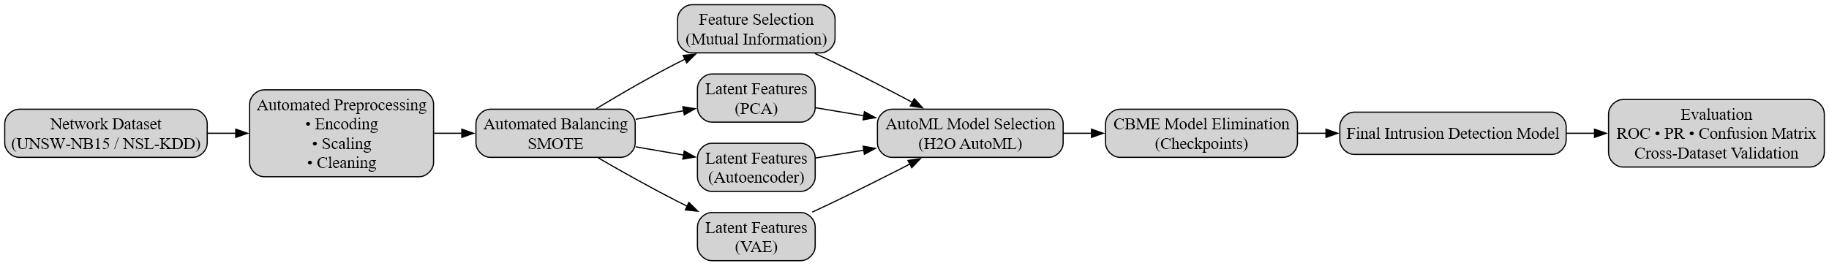
Figure 3.1: Proposed Feature-Centric AutoML Anomaly Detection Pipeline
As shown in Figure 3.1, the pipeline begins with preprocessing and balancing, followed by multiple feature generation paths including mutual information and representation learning. These are then evaluated using AutoML and refined using CBME before final evaluation.
Subsequently, feature selection techniques such as mutual information, correlation filtering, and checkpoint-based model elimination (CBME) are applied to identify the most relevant features and eliminate redundancy. This stage ensures that only the most informative feature subsets are retained for model training.
The refined feature sets are then used as input to the H2O AutoML framework, which automatically trains and evaluates multiple machine learning models. The framework performs model selection, hyperparameter optimisation, and ensemble generation to identify the best-performing model configuration.
Model performance is evaluated using multiple metrics, including Precision, Recall, F1-score, ROC-AUC, and False Positive Rate (FPR), providing a comprehensive assessment of detection capability. In addition, computational efficiency is evaluated in terms of inference time and estimated energy consumption to assess the practicality of the proposed approach.

Data Preprocessing and Feature Engineering
Data preprocessing and feature engineering are essential stages in preparing network traffic data for anomaly detection. The UNSW-NB15 dataset contains a mixture of numerical and categorical features, requiring systematic transformation to ensure compatibility with machine learning models.
Initially, irrelevant and non-informative attributes, including unique identifiers and categorical labels such as “id” and “attack_cat”, are removed to prevent data leakage and bias during model training. The target variable is retained as a binary classification label representing normal and anomalous traffic.
Categorical features, including protocol type (“proto”), service (“service”), and connection state (“state”), are transformed into numerical representations using encoding techniques. One-hot encoding is applied to convert these attributes into binary feature vectors, allowing effective use by machine learning algorithms.
Numerical features are standardised to ensure consistent scaling across all attributes. Feature scaling normalises value distributions, preventing features with larger ranges from dominating the learning process. This step is important for algorithms sensitive to feature magnitude and improves model stability.
To enhance feature representation, additional transformations are applied where necessary, including statistical and distribution-based adjustments. These transformations improve the separability of normal and anomalous traffic patterns within the feature space.
A key challenge in anomaly detection is class imbalance, where normal traffic instances outnumber anomalous instances. To address this, the Synthetic Minority Over-sampling Technique (SMOTE) is applied to the training dataset. SMOTE generates synthetic samples for the minority class, resulting in a more balanced distribution and improving the model’s ability to detect anomalies.
Following preprocessing and transformation, the dataset is converted into a high-dimensional feature space, with categorical expansion increasing the number of features. This processed dataset serves as input for subsequent representation learning and feature selection stages.
These preprocessing and feature engineering steps ensure that the dataset is clean, structured, and optimised for effective anomaly detection, providing a strong foundation for the automated modelling pipeline.

Representation Learning
Representation learning is applied in this study to improve the quality and structure of feature representations derived from network traffic data. After preprocessing and feature engineering, the dataset becomes high-dimensional due to categorical encoding and feature expansion. High-dimensional data may introduce redundancy, noise, and increased computational complexity, negatively impacting model performance. Therefore, representation learning techniques are used to transform the original feature space into more compact and informative representations.
This study incorporates both linear and non-linear representation learning techniques, including Principal Component Analysis (PCA), Autoencoders (AE), and Variational Autoencoders (VAE), to generate latent feature representations and evaluate their impact on anomaly detection performance.
Principal Component Analysis (PCA) is applied as a linear dimensionality reduction technique. PCA transforms the feature space into orthogonal components that capture maximum variance. By projecting data onto a reduced number of components, PCA removes redundancy while preserving important structural information, this improves computational efficiency and reducing feature complexity while maintaining key characteristics.
In addition to linear methods, non-linear representation learning is implemented using Autoencoders. Autoencoders are neural network-based models that reconstruct input data through a compressed latent representation. By learning lower-dimensional embeddings of network traffic features, autoencoders capture complex non-linear relationships that may not be identified using linear methods. The latent features generated are then used as input for classification.
Variational Autoencoders (VAE) are also explored as an extension of standard autoencoders. VAEs introduce a probabilistic approach by modelling the latent space as a distribution rather than a fixed encoding. This enables smoother and more generalised feature representations, improving robustness to variations in network traffic.
These representation learning techniques are integrated into the experimental pipeline to generate alternative feature sets, which are evaluated using the AutoML framework. By comparing PCA-based, autoencoder-based, and VAE-based representations, this study assesses the effectiveness of different transformation strategies in improving anomaly detection performance and reducing false positives.
The inclusion of both linear and non-linear representation learning methods enables evaluation of how dimensionality reduction and feature abstraction influence the performance of automated anomaly detection systems.

Feature Selection and Optimisation
Feature selection and optimisation are critical stages in improving the performance and efficiency of anomaly detection systems. After preprocessing and representation learning, the dataset contains large number of features, including both original and transformed attributes. High-dimensional feature spaces can introduce redundancy, increase computational cost, and negatively impact model generalisation. Therefore, feature selection techniques are applied to identify the most informative features while reducing noise and redundancy.
This study employs a combination of filter-based and performance-driven feature selection methods, including mutual information, correlation analysis, and checkpoint-based model elimination (CBME), to refine the feature set.
Mutual information is used as an initial technique to measure the dependency between each feature and the target variable. Features with higher mutual information scores are considered more relevant for classification, allowing the removal of less informative features at an early stage while preserving important information.
Correlation analysis is applied to identify highly correlated features. Strong correlations may indicate redundancy, where multiple features capture similar information. Removing these features reduces model complexity and helps minimise overfitting, improving generalisation.
To further refine the feature set, checkpoint-based model elimination (CBME) is implemented as a performance-driven optimisation strategy. In this approach, feature subsets are iteratively evaluated using performance metrics such as F1-score and ROC-AUC. At each iteration, less informative features are removed, and the model is retrained to assess the impact on performance. This process continues until an optimal subset is identified that balances accuracy and efficiency.
Unlike traditional methods, CBME uses feedback from model performance to guide the optimisation process, ensuring that feature selection decisions align with detection effectiveness. This iterative refinement enables the identification of a compact and informative feature set, improving both efficiency and detection accuracy.
The final selected feature subset is then used as input for the AutoML training stage, ensuring that models are trained on optimised features. This optimisation process plays a key role in enhancing anomaly detection performance while reducing model complexity.

AutoML Model Training
To automate the model development process and reduce reliance on manual configuration, this study employs the H2O AutoML framework for training and optimisation. AutoML streamlines machine learning workflows by performing model selection, hyperparameter tuning, and ensemble construction, enabling efficient exploration of multiple model configurations.
Following feature optimisation, the selected feature subsets are used as input to the AutoML framework. The training process involves automatically generating and evaluating a range of machine learning models, including tree-based and ensemble methods. The framework iteratively trains candidate models and ranks them based on performance metrics, allowing identification of the most effective model for anomaly detection.
A key advantage of H2O AutoML is its ability to construct ensemble models, such as stacked ensembles, which combine predictions from multiple base models to improve overall performance. These ensembles leverage the strengths of individual models while reducing variance and bias, resulting in more robust predictions.
Hyperparameter optimisation is performed automatically within the AutoML process. Instead of manual tuning, the framework explores different configurations and selects optimal settings based on evaluation results. This reduces the need for manual intervention and ensures a more systematic and reproducible training process.
The AutoML training is conducted using the processed and optimised dataset, ensuring that models are trained on high-quality feature representations. The framework produces a leaderboard of models ranked by performance, providing transparency into the selection process and enabling comparison across algorithms.
The final model is selected based on key evaluation metrics, including F1-score and ROC-AUC, with emphasis on balancing detection accuracy and false positive rate. This ensures that the selected model is both accurate and practical for real-world anomaly detection.
By integrating AutoML into the pipeline, this study achieves an automated training process, reducing complexity while improving efficiency, scalability, and reproducibility in network anomaly detection.

Model Evaluation Metrics
To assess the performance of the proposed anomaly detection framework, multiple evaluation metrics are used to provide a comprehensive analysis. In network intrusion detection, relying solely on accuracy is insufficient due to class imbalance and the importance of correctly identifying anomalous behaviour. Therefore, a multi-metric evaluation approach is adopted.
Precision measures the proportion of correctly identified anomalous instances among all predicted anomalies and is defined as:
Precision = TP / (TP + FP)
where TP represents true positives and FP represents false positives. High precision indicates a low number of false positives, which is important for reducing unnecessary alerts.
Recall measures the proportion of actual anomalous instances correctly detected by the model and is defined as:
Recall = TP / (TP + FN)
where FN represents false negatives. This metric is critical in cybersecurity, where failing to detect an attack can have serious consequences.
The F1-score provides a combined measure of precision and recall and is defined as:
F1-score = 2 × (Precision × Recall) / (Precision + Recall)
This metric is useful for imbalanced datasets, ensuring both detection accuracy and reliability are considered.
The Receiver Operating Characteristic Area Under the Curve (ROC-AUC) evaluates the model’s ability to distinguish between normal and anomalous traffic across different thresholds. Higher ROC-AUC values indicate better discrimination.
The False Positive Rate (FPR) is explicitly considered and is defined as:
FPR = FP / (FP + TN)
where TN represents true negatives. In intrusion detection, a high false positive rate can lead to alert fatigue and reduced trust in the system. Therefore, minimising FPR is essential.
In addition to classification performance, computational efficiency is evaluated to assess practicality. Metrics such as inference time and processing speed (rows per second) are used to measure how efficiently the model processes network traffic.
Furthermore, energy consumption is estimated based on model execution time and assumed hardware power usage. This allows evaluation of the operational cost of the model, aligning with research on efficient machine learning.
By combining performance and efficiency metrics, this evaluation framework provides a comprehensive assessment of detection effectiveness and real-world applicability.

Deployment Demonstration
To demonstrate the practical applicability of the proposed anomaly detection framework, a simplified deployment scenario is considered. The trained model, generated using the H2O AutoML framework, can be exported and used to perform real-time or batch-based anomaly detection on network traffic data.
In this study, the final trained model is saved and can be reloaded for inference without retraining. Incoming network traffic data is first passed through the same preprocessing pipeline used during training, including feature encoding, scaling, and transformation. The processed data is then fed into the trained model, which outputs predictions indicating whether each instance is normal or anomalous.
The deployment process consists of the following steps:
- Load the saved preprocessing pipeline and trained model
- Input new network traffic data
- Apply preprocessing transformations to ensure consistency with training data
- Generate predictions using the trained model
- Interpret the output for anomaly detection
This pipeline can be integrated into real-world systems such as network monitoring tools, security information and event management (SIEM) systems, or cloud-based security platforms. The use of automated feature selection and model optimisation ensures that the system can operate with minimal manual intervention.
Furthermore, the evaluation of inference time and processing speed demonstrates that the framework can handle large volumes of network traffic efficiently. This highlights its suitability for deployment in real-time or near real-time intrusion detection environments.
Overall, the deployment demonstration confirms that the proposed AutoML-based framework is effective in detection performance and practical for real-world cybersecurity applications.

Challenges and Limitations
During the development and implementation of the proposed anomaly detection framework, several technical challenges were encountered. Addressing these challenges was essential to ensure the robustness, reliability, and effectiveness of the system.
One of the primary challenges was class imbalance within the datasets. In both UNSW-NB15 and NSL-KDD, normal and attack instances were not evenly distributed, which could bias the model towards majority classes and reduce its ability to detect anomalies. To address this issue, the Synthetic Minority Over-sampling Technique (SMOTE) was applied to balance the training data. This improved the model’s ability to learn representative patterns of minority classes and enhanced detection performance.
Another challenge was the high dimensionality of network traffic features. Large numbers of features can introduce redundancy, increase computational complexity, and negatively impact model performance. This was addressed through feature selection and dimensionality reduction techniques. Mutual information and correlation-based methods were used to identify relevant features, while representation learning techniques such as PCA and autoencoders were applied to generate compact feature representations.
The optimisation of model performance also presented complexity. Selecting appropriate models and tuning hyperparameters manually is time-consuming and requires expert knowledge. To overcome this, the H2O AutoML framework was used to automate model selection, hyperparameter optimisation, and ensemble generation. This reduced manual intervention and enabled systematic exploration of model configurations.
During experimentation, certain models such as XGBoost were not consistently available within the AutoML process due to compatibility or configuration limitations. This required adaptation of the experimental setup and the use of alternative models such as Gradient Boosting Machines and Stacked Ensembles, which still provided strong performance.
Another challenge involved balancing detection performance with computational efficiency. High-performing models can require increased processing time and resources, which may limit real-world applicability. To address this, the study included evaluation of inference speed and energy consumption, enabling assessment of both performance and efficiency.
Finally, ensuring generalisation across datasets was a key challenge. Models trained on a single dataset may not perform well on different environments due to dataset shift. This was addressed by evaluating the framework on multiple benchmark datasets, enabling a more robust assessment of generalisation.
Overall, these challenges highlight the complexity of developing practical anomaly detection systems. The solutions implemented demonstrate the importance of combining preprocessing, feature optimisation, automated model selection, and efficiency evaluation within a unified framework.

Results and Discussion

Experimental Setup
All experiments in this study were conducted on a personal computing system running a 64-bit Windows operating system. The system utilised CPU-based processing without GPU acceleration, reflecting a typical mid-range computing environment.
Component | Specification
CPU | Intel Core i5-1035G1 (1.00–1.19 GHz)
RAM | 16 GB
Storage | 932 GB
GPU | Intel UHD Graphics (integrated)
Operating System | 64-bit Windows
Processing | CPU-based (No GPU acceleration)
Table 4.1: System configuration
The implementation was carried out using Python within a Jupyter Notebook environment. Key libraries included Pandas for data manipulation, Scikit-learn for preprocessing and evaluation, and imbalanced-learn for handling class imbalance using the Synthetic Minority Over-sampling Technique (SMOTE). The H2O AutoML framework was used for automated model training, hyperparameter optimisation, and model selection. Model interpretability was achieved using SHAP (SHapley Additive exPlanations), while visualisation was performed using Matplotlib.
The experimental evaluation was conducted using two benchmark datasets: UNSW-NB15 and NSL-KDD. UNSW-NB15 was used as the primary dataset due to its representation of modern network traffic and diverse attack categories, while NSL-KDD was used to assess generalisation capability across different data distributions. The anomaly detection task was formulated as a binary classification problem, where traffic instances were labelled as either normal or anomalous.
To evaluate the impact of feature representation on anomaly detection performance, multiple feature configurations were generated. The baseline configuration consisted of preprocessed features, including encoded categorical attributes and scaled numerical features. Mutual information-based feature selection was applied to identify the most informative features. In addition, representation learning techniques such as Principal Component Analysis (PCA), Autoencoders (AE), and Variational Autoencoders (VAE) were used to generate latent feature representations. Checkpoint-based model elimination (CBME) was further applied to iteratively refine feature subsets based on model performance. Class imbalance was addressed using SMOTE to ensure balanced training data.
Model performance was evaluated using multiple metrics, including Area Under the Curve (AUC), F1-score, Precision, Recall, and False Positive Rate (FPR). In addition to detection performance, operational metrics such as inference throughput (rows per second) and estimated energy consumption were measured to assess the practicality of the proposed system.

Feature Representation and Performance Comparison
To evaluate the impact of feature representation on anomaly detection performance, multiple feature configurations were compared, including baseline features, dimensionality reduction techniques, and representation learning approaches.
The baseline feature set was constructed using pre-processed network traffic features with mutual information-based feature selection applied to retain the most informative attributes. This configuration serves as a reference point for evaluating the effectiveness of more advanced feature transformation techniques.
Principal Component Analysis (PCA) was used to generate a lower-dimensional representation of the data by capturing the maximum variance across orthogonal components. While PCA reduces feature dimensionality and computational complexity, its linear nature may limit its ability to capture complex non-linear relationships within network traffic data.
To address this limitation, non-linear representation learning techniques were applied using Autoencoders (AE) and Variational Autoencoders (VAE). These models learn compressed latent representations of the input data, enabling the capture of more complex feature interactions. The results demonstrate that latent feature representations improve model performance compared to traditional linear transformations.
Furthermore, checkpoint-based model elimination (CBME) was applied to iteratively refine feature subsets based on model performance. This approach enabled the identification of an optimal subset of features that balances performance and efficiency.
As shown in Table 4.2, the mutual information and CBME-based feature configuration achieved the highest overall performance, demonstrating superior F1-score and AUC values while maintaining a low false positive rate. In contrast, PCA-based features showed reduced performance due to the loss of important non-linear feature relationships. Autoencoder-based representations provided competitive results, indicating their effectiveness in capturing latent structures within network traffic data.
Overall, the results highlight that feature engineering plays a critical role in anomaly detection performance. Automated feature selection and optimisation techniques, particularly those based on mutual information and CBME, provide a strong foundation for improving detection accuracy while maintaining efficiency.
Feature Method | AUC | F1 | Precision | Recall | FPR
MI + CBME (Proposed) | 0.9846 | 0.9365 | 0.9578 | 0.9161 | 0.0494
Autoencoder Latent | 0.9727 | 0.9093 | 0.9387 | 0.8817 | 0.0706
PCA Latent | 0.9680 | 0.9024 | 0.9338 | 0.8730 | 0.0759
VAE Latent | 0.9664 | 0.8994 | 0.9053 | 0.8937 | 0.1146
Table 4.2: Performance Comparison of Feature Engineering Techniques
The results presented in Table 4.2 clearly demonstrate that the MI + CBME feature configuration achieved the best overall performance across multiple evaluation metrics. It obtained the highest AUC (0.9846) and F1-score (0.9365), while also maintaining the lowest false positive rate (0.0494), indicating strong detection capability with reduced false alarms.
In comparison, PCA-based features showed lower performance, likely due to their inability to capture complex non-linear relationships within network traffic data. Autoencoder and variational autoencoder representations improved performance over PCA by learning latent feature structures; however, they did not outperform the MI + CBME configuration.
These findings highlight that effective feature selection and optimisation play a more critical role in anomaly detection performance than dimensionality reduction alone. The results support the use of automated feature optimisation techniques as a key component of robust intrusion detection systems.

AutoML Model Leaderboard
To evaluate the effectiveness of automated model selection and optimisation, the H2O AutoML framework was used to generate and compare multiple machine learning models. AutoML automatically trains a range of algorithms, including Gradient Boosting Machines (GBM), Distributed Random Forest (DRF), and Generalised Linear Models (GLM), while optimising hyperparameters and model configurations.
The performance of all trained models was ranked using a leaderboard based on Area Under the Curve (AUC). The leaderboard provides a comparative overview of model performance, enabling the identification of the most effective model without manual tuning.
As shown in Figure 4.1, the top-performing models were Gradient Boosting Machine (GBM) variants, which consistently achieved the highest AUC values among all evaluated models. This indicates that GBM is particularly effective at capturing complex non-linear relationships within network traffic data.
The strong performance of GBM models can be attributed to their ensemble-based structure, where multiple decision trees are combined to improve predictive accuracy and reduce error. This makes them well-suited for high-dimensional and heterogeneous datasets such as UNSW-NB15.
In comparison, other models such as Distributed Random Forest (DRF) and Generalised Linear Models (GLM) demonstrated slightly lower performance. While these models are effective in certain contexts, they may be less capable of modelling complex interactions between features compared to boosting-based approaches.
The use of AutoML significantly reduced the need for manual model selection and hyperparameter tuning, allowing systematic exploration of multiple model configurations. This supports the objective of developing an automated and scalable anomaly detection framework.
Overall, the AutoML leaderboard results demonstrate that automated model optimisation, particularly through Gradient Boosting techniques, can achieve high detection performance while reducing manual effort and improving reproducibility.

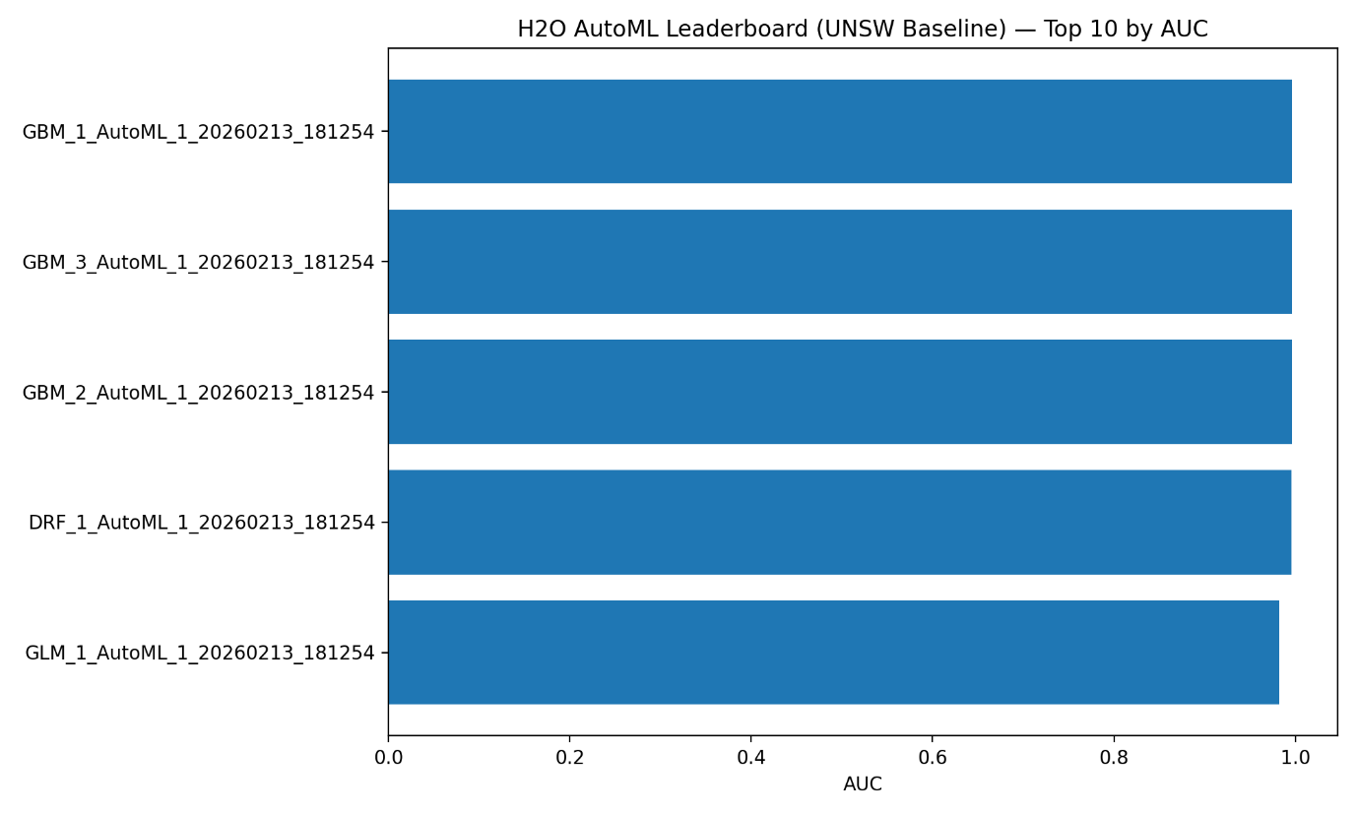
Figure 4.1: H2O AutoML leaderboard showing the top-performing models ranked by AUC on the UNSW-NB15 dataset.

ROC and Precision-Recall Curves
To further evaluate the performance of different feature configurations, Receiver Operating Characteristic (ROC) curves and Precision-Recall (PR) curves were analysed. These curves provide a visual assessment of model performance across different classification thresholds and offer deeper insight beyond single-value metrics.
Figure 4.2 presents the ROC curve comparison for the evaluated feature configurations. The ROC curve illustrates the trade-off between the true positive rate (TPR) and false positive rate (FPR). A curve closer to the top-left corner indicates better classification performance.
As shown in Figure 4.2, the MI + CBME (baseline) configuration consistently outperforms the other approaches, achieving the highest AUC value of 0.9846. Its curve remains above the other models across all threshold values, indicating superior ability to distinguish between normal and anomalous traffic. In contrast, PCA and VAE-based representations show lower performance, with their curves positioned further from the optimal region, reflecting weaker discrimination capability. The autoencoder-based representation demonstrates improved performance over PCA and VAE, but still does not surpass the MI + CBME configuration.
Figure 4.3 presents the Precision-Recall curve comparison, which is particularly important for imbalanced classification problems such as anomaly detection. The PR curve highlights the relationship between precision and recall, providing insight into how well the model maintains accuracy when identifying anomalies.
The results show that the MI + CBME configuration again achieves the best performance, maintaining higher precision across a wide range of recall values, with an average precision (AP) score of 0.9887. This indicates that the model is highly effective at correctly identifying anomalous traffic while minimising false positives. The autoencoder-based approach provides competitive performance, while PCA and VAE configurations demonstrate a noticeable decline in precision as recall increases.
Overall, both ROC and Precision-Recall curve analyses confirm that the MI + CBME feature configuration provides the most robust and reliable performance. These results reinforce the importance of effective feature selection and optimisation in improving anomaly detection systems.
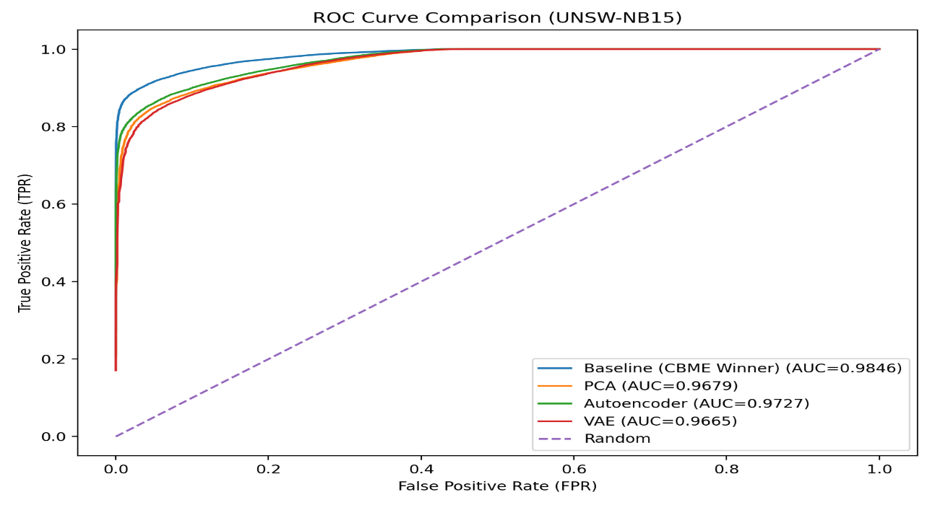
Figure 4.2: ROC curve comparison of feature configurations on the UNSW-NB15 dataset.
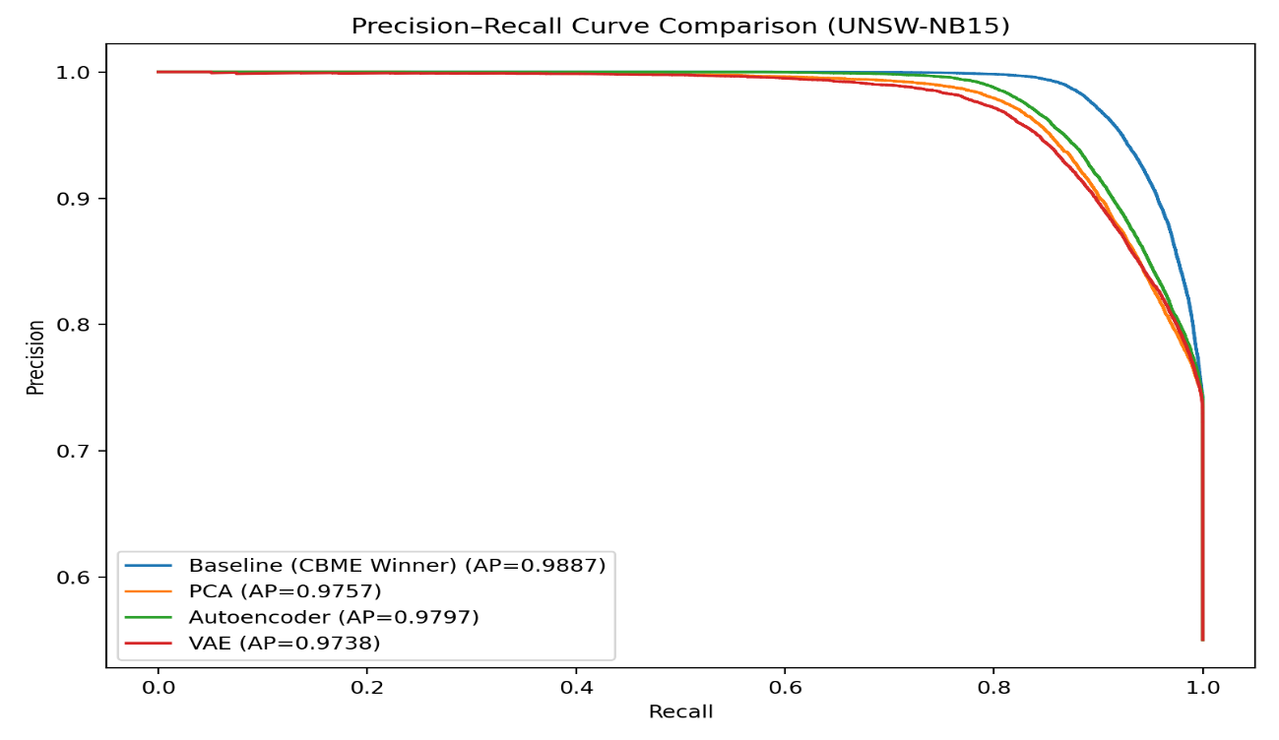
Figure 4.3: Precision-Recall curve comparison of feature configurations on the UNSW-NB15 dataset.

Confusion Matrix
To provide a detailed evaluation of classification performance, a confusion matrix was analysed for the best-performing model using the MI + CBME feature configuration. The confusion matrix presents the distribution of correctly and incorrectly classified instances, offering insight into the types of errors made by the model.
Figure 4.4 illustrates the confusion matrix for the UNSW-NB15 dataset at the optimal decision threshold. The model correctly classified 35,169 normal instances (true negatives) and 41,496 attack instances (true positives), demonstrating strong detection capability across both classes.
The model produced 1,831 false positives, where normal traffic was incorrectly classified as anomalous. This results in a relatively low false positive rate, which is critical in intrusion detection systems to avoid unnecessary alerts and reduce operational overhead. Additionally, 3,836 false negatives were observed, indicating cases where malicious traffic was not detected.
The balance between false positives and false negatives reflects the trade-off inherent in anomaly detection systems. While reducing false positives is important for maintaining system usability, false negatives represent missed attacks and therefore remain a critical consideration.
Overall, the confusion matrix confirms that the proposed feature configuration achieves strong classification performance, with high true positive and true negative rates while maintaining a low false positive rate. This supports the effectiveness of the model in detecting anomalous network behaviour in practical deployment scenarios.
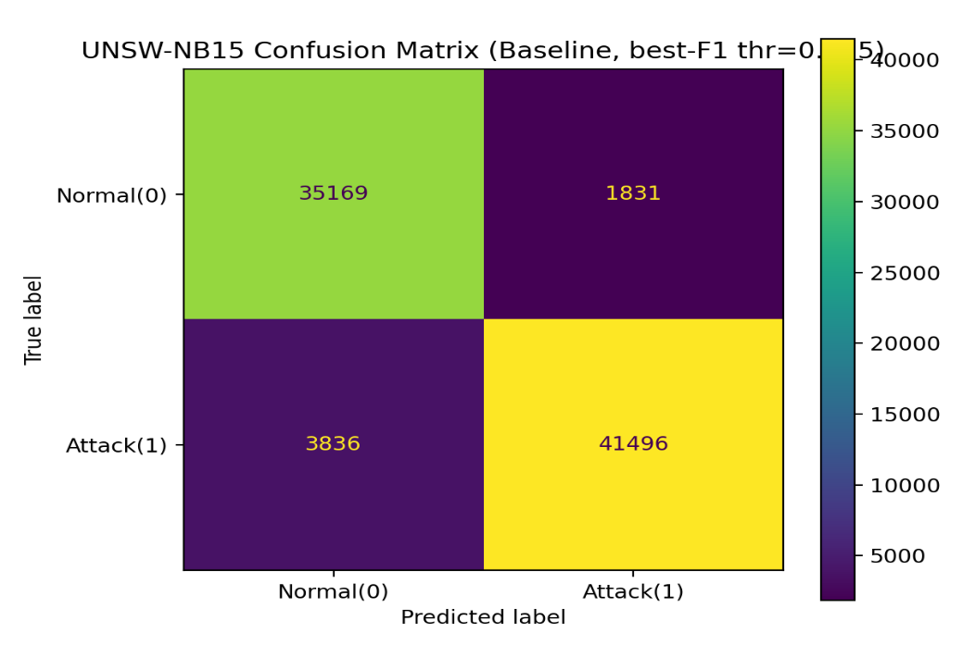
Figure 4.4: Confusion matrix for the MI + CBME model on the UNSW-NB15 dataset at the optimal classification threshold.
The relatively low number of false positives aligns with the previously reported low FPR, further confirming the reliability of the model.

SHAP Feature Importance
To improve model interpretability and understand the contribution of individual features, SHAP (SHapley Additive exPlanations) analysis was performed on the best-performing model using the MI + CBME feature configuration. SHAP values quantify the impact of each feature on the model’s predictions, allowing identification of the most influential variables in anomaly detection.
Figure 4.5 presents the top 20 most important features ranked by their average contribution to the model output. The results show that features such as sttl, ct_state_ttl, and spkts have the highest influence on classification decisions. In particular, sttl (source time-to-live) demonstrates a significantly higher contribution compared to other features, indicating its strong relevance in distinguishing between normal and anomalous network traffic.
Other important features, including ct_dst_sport_ltm, smean, and rate, capture statistical and behavioural characteristics of network flows, such as packet distribution, connection patterns, and transmission rates. These features reflect underlying communication behaviour and are therefore highly informative for anomaly detection.
The prominence of these features suggests that temporal and statistical attributes play a critical role in identifying abnormal network activity. Features related to connection state transitions and packet-level statistics contribute significantly to the model’s ability to detect malicious patterns.
Overall, the SHAP analysis confirms that the model relies on meaningful and interpretable network traffic features rather than arbitrary patterns. This enhances trust in the model’s predictions and supports its applicability in real-world intrusion detection systems, where explainability is an important requirement.

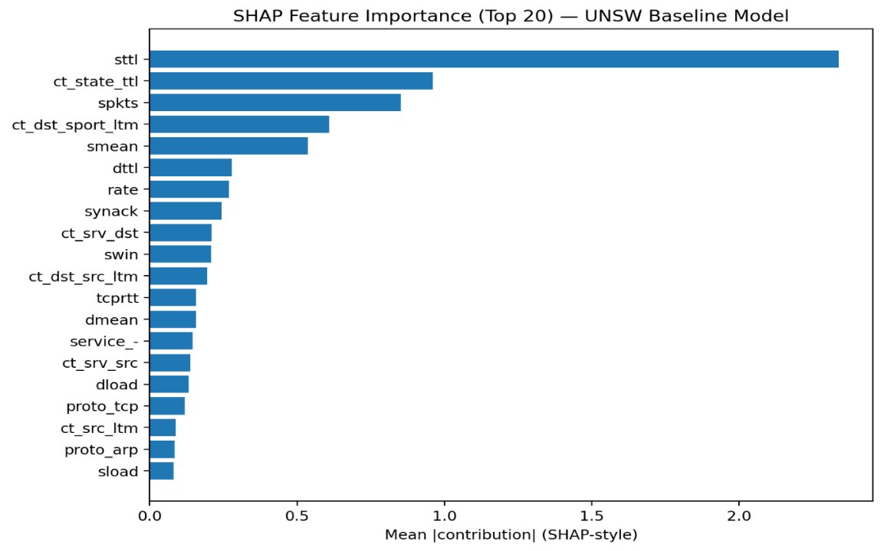
Figure 4.5: SHAP feature importance showing the top 20 most influential features for the MI + CBME model on the UNSW-NB15 dataset.
These findings align with the feature selection process, further validating the effectiveness of the proposed feature optimisation strategy.

Energy and Latency Analysis
In addition to detection performance, the computational efficiency of the proposed anomaly detection framework was evaluated to assess its suitability for real-world deployment. This includes analysis of inference speed and estimated energy consumption during model execution.
The results show that the proposed framework achieves high processing efficiency, with the UNSW-NB15 dataset reaching an inference throughput of approximately 75,080 rows per second, while the NSL-KDD dataset achieved 47,878 rows per second. This indicates that the model can handle large volumes of network traffic in near real-time scenarios.
Energy consumption was estimated based on model execution time and assumed system power usage. As shown in Table 4.3, the framework demonstrates low energy consumption across both datasets. For UNSW-NB15, the estimated energy usage is approximately 0.0002 kWh per one million processed rows, while NSL-KDD requires approximately 0.0003 kWh.
The corresponding carbon footprint (CO₂ emissions) is also minimal, reflecting the relatively low computational cost of the model during inference. These results indicate that the proposed framework is not only effective in detection performance but also efficient in terms of resource utilisation.
Overall, the energy and latency analysis demonstrates that the feature-centric AutoML framework provides a strong balance between detection accuracy and computational efficiency. This supports its applicability in practical deployment environments where both performance and resource consumption are critical considerations.
Dataset | Energy (kWh test) | Energy per 1M rows | CO₂ per 1M rows
UNSW-NB15 | 0.000008 | 0.0002 | ~0.0000
NSL-KDD | 0.000006 | 0.0003 | ~0.0001
Table 4.3: Energy consumption and efficiency analysis for model inference across datasets.

Final Result Summary
The final results summary combines detection performance and operational efficiency metrics for the best-performing models across both benchmark datasets. This provides an overall view of how the proposed framework performs not only in terms of classification accuracy, but also in practical deployment-related factors such as throughput and estimated energy consumption.
Table 4.4 presents the final comparison between the UNSW-NB15 and NSL-KDD datasets. The results show that the model achieved stronger overall detection performance on UNSW-NB15, with an AUC of 0.985, an F1-score of 0.936, and a low false positive rate of 0.049. In addition, the model maintained high throughput of 75,080 rows per second and low estimated energy consumption of 0.0002 kWh per one million processed rows.
On the NSL-KDD dataset, the model also achieved strong classification performance, with an AUC of 0.945 and an F1-score of 0.906. However, the false positive rate was higher at 0.190, and throughput was lower at 47,878 rows per second. Estimated energy consumption was slightly higher at 0.0003 kWh per one million rows.
These findings indicate that the proposed framework performs most effectively on the UNSW-NB15 dataset, while still demonstrating reasonable generalisation on NSL-KDD. Overall, the results show that the proposed AutoML-based anomaly detection framework achieves a strong balance between detection performance and computational efficiency, supporting its suitability for practical and scalable intrusion detection scenarios.
Dataset | AUC | F1 | Precision | Recall | FPR | Throughput | Energy (kWh per 1M rows)
UNSW-NB15 | 0.985 | 0.936 | 0.958 | 0.916 | 0.049 | 75,080 | 0.0002
NSL-KDD | 0.945 | 0.906 | 0.868 | 0.948 | 0.190 | 47,878 | 0.0003
Table 4.4: Final performance and efficiency summary for the best-performing models across datasets.

Comparison with Existing Studies
The performance of the proposed anomaly detection framework is compared with selected studies from the literature, as shown in Table 4.5. Previous studies using traditional machine learning models, such as Random Forest and Extra Trees, report high classification performance, with F1-scores reaching approximately 0.98 on both the UNSW-NB15 and NSL-KDD datasets. Similarly, feature engineering-based approaches demonstrate very high performance, achieving F1-scores of up to 0.996 on UNSW-NB15. Deep learning-based methods, including convolutional and neural network models, generally report lower performance, with F1-scores around 0.904 for UNSW-NB15 and 0.800 for NSL-KDD.
In comparison, the proposed AutoML-based framework achieves an F1-score of 0.936 and an AUC of 0.985 on the UNSW-NB15 dataset, along with an F1-score of 0.906 on NSL-KDD. While some existing approaches report higher classification metrics, these results are typically obtained using manually optimised feature engineering techniques or dataset-specific configurations.
It is important to note that direct comparison across studies is limited due to differences in preprocessing, data splits, and evaluation methodologies. Many studies also do not report the False Positive Rate (FPR), which is critical in practical intrusion detection systems. In contrast, this study explicitly evaluates FPR, achieving a low value of 0.049 on UNSW-NB15.
Furthermore, the proposed framework utilises a fully automated pipeline through AutoML, reducing reliance on manual feature engineering and model tuning. This enhances scalability, reproducibility, and applicability across different datasets. Additionally, the use of cross-dataset evaluation further strengthens the reliability of the results.
Overall, the findings demonstrate that the proposed approach achieves competitive performance while providing advantages in automation, efficiency, and real-world deployment suitability.
Study | Dataset | AUC | F1 | Precision | Recall | FPR | Approach
This Study | UNSW-NB15 | 0.985 | 0.936 | 0.958 | 0.916 | 0.049 | AutoML + CBME
This Study | NSL-KDD | 0.945 | 0.906 | 0.868 | 0.948 | 0.190 | AutoML + CBME
Fuat TÜRK (2023) | UNSW-NB15 | N/A | 0.980 | 0.980 | 0.980 | N/A | Traditional ML (RF)
Fuat TÜRK (2023) | NSL-KDD | N/A | 0.980 | 0.970 | 0.980 | N/A | Traditional ML (MLP)
Talukder & Moni (2017) | UNSW-NB15 | N/A | 0.996 | 0.996 | 0.996 | N/A | Feature Engineering
Al-Turaiki & Altwaijry (2021) | UNSW-NB15 | N/A | 0.904 | 0.910 | 0.900 | N/A | Deep Learning
Al-Turaiki & Altwaijry (2021) | NSL-KDD | N/A | 0.800 | 0.830 | 0.810 | N/A | Deep Learning
Table 4.5: Performance comparison of the proposed framework with existing studies
It should be noted that the proposed model was primarily developed and optimised using the UNSW-NB15 dataset, while NSL-KDD was used to evaluate cross-dataset generalisation capability.

Research Questions Evaluation
This section evaluates the research questions defined in Chapter 1 based on the experimental findings of this study.
Research Question 1: How can a feature-focused AutoML system be designed to automatically generate and select the most effective feature representations in order to improve anomaly detection performance using the UNSW-NB15 network security dataset?
The results demonstrate that a feature-focused AutoML system can be effectively designed by integrating preprocessing, automated feature selection, representation learning, and model optimisation within a unified pipeline. In this study, feature representations were generated using techniques such as Principal Component Analysis (PCA), Autoencoders (AE), and Variational Autoencoders (VAE), while feature selection was performed using mutual information and checkpoint-based model elimination (CBME). The MI + CBME configuration achieved the best performance, with an AUC of 0.9846 and F1-score of 0.9365, demonstrating that automated feature optimisation can significantly improve anomaly detection performance on the UNSW-NB15 dataset.
This directly answers the first research question by demonstrating that a structured AutoML pipeline integrating feature optimisation can effectively generate and select high-quality feature representations for anomaly detection.
Research Question 2: What impact do automated feature engineering and representation learning techniques have on intrusion detection accuracy and overall model performance?
The experimental results show that automated feature engineering and representation learning techniques have a substantial impact on model performance. PCA-based features resulted in lower performance due to their linear nature, while Autoencoder and Variational Autoencoder approaches improved detection performance by capturing non-linear feature relationships. However, feature selection techniques such as mutual information combined with CBME produced the highest accuracy, indicating that selecting the most relevant features is more effective than transformation alone. These findings highlight that automated feature engineering plays a critical role in improving intrusion detection accuracy.
This confirms that automated feature engineering and representation learning significantly influence model performance, validating their role within the proposed AutoML framework.
Research Question 3: How can feature selection strategies and feedback-based model refinement contribute to reducing false positives and improving detection reliability in network anomaly detection systems?
The results confirm that feature selection strategies and feedback-based refinement significantly contribute to reducing false positives and improving detection reliability. The MI + CBME approach achieved the lowest false positive rate of 0.0494, demonstrating its effectiveness in minimising incorrect alerts. CBME, as a feedback-based model refinement strategy, iteratively removed less informative features based on model performance, leading to a more optimised feature set. This process improved the model’s ability to distinguish between normal and anomalous traffic, thereby enhancing overall detection reliability.
This demonstrates that feedback-driven feature optimisation strategies such as CBME are effective in reducing false positives and improving detection reliability.
Overall, the findings demonstrate that combining automated feature engineering, representation learning, and feedback-driven feature selection within an AutoML framework leads to improved anomaly detection performance, reduced false positives, and enhanced model robustness. Furthermore, cross-dataset evaluation on NSL-KDD confirms that the proposed approach maintains reasonable generalisation beyond the primary dataset.

Critical Reflection
This study involved the design and evaluation of a feature-centric AutoML framework for network anomaly detection, requiring several key methodological decisions and adaptations throughout the implementation process.
One of the main challenges encountered was determining the most effective feature representation strategy. While representation learning techniques such as PCA, Autoencoders, and Variational Autoencoders were initially expected to outperform traditional feature selection methods, the experimental results revealed that feature selection techniques, particularly mutual information combined with CBME, produced superior performance. This highlights the importance of selecting relevant features over relying solely on feature transformation techniques.
Another important consideration was the transition from manual model optimisation to a fully automated pipeline. Initial experimentation indicated that manually tuned models could achieve strong performance; however, such approaches lack scalability and reproducibility. The adoption of an AutoML-based framework addressed these limitations by enabling systematic exploration of model configurations and reducing reliance on manual intervention. However, the use of AutoML introduces a trade-off between automation and interpretability, as the model selection and optimisation process becomes less transparent compared to manually designed approaches.
The study also required balancing detection performance with computational efficiency. While achieving high accuracy was a primary objective, additional evaluation of throughput and estimated energy consumption highlighted the importance of developing practical and deployable solutions. This reflects real-world requirements where intrusion detection systems must operate efficiently under continuous data streams.
Despite the strong performance achieved, certain limitations were identified. Energy consumption was estimated based on system assumptions rather than directly measured, which may affect the precision of efficiency analysis. Additionally, evaluation was conducted on benchmark datasets, which may not fully represent the complexity of real-world network environments.
Overall, this study highlights that while automated approaches significantly improve scalability and performance, careful consideration of feature optimisation strategies remains critical. The findings emphasise that effective anomaly detection is not solely dependent on advanced models, but on the quality and optimisation of feature representations.

Conclusion and Future work

Summary of Findings
This study investigated the design and evaluation of a feature-centric AutoML framework for network anomaly detection, with a focus on improving detection performance through automated feature optimisation and model selection. The experimental results demonstrate that feature representation plays a critical role in determining anomaly detection effectiveness.
Among the evaluated approaches, the combination of mutual information-based feature selection and checkpoint-based model elimination (CBME) achieved the highest overall performance on the UNSW-NB15 dataset. This configuration produced an AUC of 0.9846 and an F1-score of 0.9365, while maintaining a relatively low false positive rate of 0.0494. These results indicate that selecting the most informative features is more effective than relying solely on dimensionality reduction or representation learning techniques.
In comparison, representation learning approaches such as Principal Component Analysis (PCA), Autoencoders (AE), and Variational Autoencoders (VAE) demonstrated moderate performance improvements but did not outperform the optimised feature selection approach. While these methods were effective in capturing latent structures within the data, their impact on overall detection performance was limited compared to feature selection techniques.
The use of the H2O AutoML framework enabled automated model selection and optimisation, resulting in high-performing models without manual intervention. Gradient Boosting Machine (GBM)-based models consistently achieved strong classification performance, demonstrating the effectiveness of AutoML in identifying optimal model configurations.
In addition to detection performance, the study evaluated computational efficiency through inference speed and estimated energy consumption. The proposed framework achieved high throughput, processing approximately 75,000 rows per second, while maintaining low estimated energy consumption. These findings suggest that the system is not only accurate but also efficient and suitable for large-scale deployment.
In addition, cross-dataset evaluation using NSL-KDD demonstrated that the proposed framework maintains reasonable generalisation capability beyond the primary dataset.
Overall, the results confirm that integrating automated feature selection, representation learning, and AutoML within a unified pipeline can significantly enhance anomaly detection performance while maintaining practical efficiency.

Contributions of the Study
This study makes several contributions to the field of network anomaly detection by proposing and evaluating a feature-centric AutoML framework designed to improve detection performance while reducing manual intervention.
First, the study introduces a structured and fully automated anomaly detection pipeline that integrates data preprocessing, feature engineering, representation learning, feature selection, and model optimisation within a unified framework. Unlike traditional intrusion detection approaches that rely heavily on manual configuration, the proposed pipeline minimises human involvement and improves reproducibility.
Second, the research provides a comparative evaluation of multiple feature representation techniques, including Principal Component Analysis (PCA), Autoencoders (AE), and Variational Autoencoders (VAE), alongside feature selection methods such as mutual information and checkpoint-based model elimination (CBME). This comparison offers insights into the relative effectiveness of linear, non-linear, and selection-based feature optimisation strategies in network anomaly detection.
Third, the study demonstrates the effectiveness of combining mutual information with feedback-based feature refinement using CBME. The results show that this approach produces a highly optimised feature subset, leading to improved detection performance and reduced false positive rates. This highlights the importance of feature selection strategies in enhancing model reliability.
Fourth, the research integrates the H2O AutoML framework into the anomaly detection pipeline, enabling automated model selection, hyperparameter tuning, and ensemble learning. This contribution shows how AutoML can be applied in cybersecurity contexts to reduce manual effort while maintaining high model performance.
Fifth, the study extends evaluation beyond traditional performance metrics by incorporating computational efficiency measures, including inference throughput and estimated energy consumption. This provides a more practical assessment of the proposed system and highlights its suitability for real-world deployment scenarios.
Finally, the study contributes to the understanding of how automated feature optimisation and model selection can be combined to create scalable and efficient anomaly detection systems. The findings provide a foundation for future research into fully automated and adaptive intrusion detection frameworks, demonstrating that effective anomaly detection is not solely dependent on advanced models, but on the systematic optimisation of feature representations within an automated pipeline.

Limitations of the Study
Despite the strong performance achieved by the proposed framework, several limitations should be acknowledged.
First, the evaluation was conducted using benchmark datasets, specifically UNSW-NB15 and NSL-KDD. While these datasets are widely used in intrusion detection research, they represent controlled environments and may not fully capture the complexity and variability of real-world network traffic. As a result, the generalisation of the proposed framework to live network environments may require further validation.
Second, the energy consumption analysis presented in this study is based on estimated values derived from system assumptions rather than direct hardware-level measurements. Although this approach provides a useful indication of computational efficiency, it may not fully reflect actual energy usage under different system configurations or deployment conditions.
Third, while the study incorporates multiple feature representation and selection techniques, the implementation is limited to a specific set of methods, including PCA, Autoencoders, Variational Autoencoders, and mutual information-based selection. Other advanced representation learning techniques and feature optimisation strategies could further enhance performance but were not explored within the scope of this work.
Additionally, the AutoML framework used in this study automates model selection and optimisation; however, it operates as a black-box system with limited interpretability regarding internal model decisions. Although SHAP was used to improve interpretability, further investigation into explainable AI techniques could provide deeper insights into model behaviour.
Finally, the experimental setup was conducted on a CPU-based system without GPU acceleration, which may limit scalability when handling significantly larger datasets or real-time high-throughput environments.
These limitations highlight opportunities for further research and development to enhance the robustness, scalability, and real-world applicability of automated anomaly detection systems, as well as the need for further validation in more dynamic and real-world environments.

Future Work
Building on the findings and limitations of this study, several directions for future research can be identified to further enhance the proposed anomaly detection framework.
First, future work should focus on evaluating the proposed system in real-world network environments. Testing the framework on live network traffic or enterprise-level datasets would provide a more comprehensive assessment of its robustness, adaptability, and practical deployment capabilities under dynamic conditions.
Second, the energy efficiency analysis could be improved by incorporating direct hardware-level power measurement tools. This would enable more accurate evaluation of energy consumption and support the development of environmentally sustainable intrusion detection systems aligned with emerging Green AI principles.
Third, further research could explore advanced representation learning techniques, including deep neural architectures and hybrid models, to enhance feature extraction and improve detection performance. Combining multiple representation learning methods may further improve feature robustness for complex network traffic.
Additionally, improving model interpretability remains an important area for future development. While SHAP was used in this study to provide feature importance insights, integrating more advanced explainable AI techniques could enhance transparency and trust in automated intrusion detection systems.
Future work could also investigate the integration of online learning and adaptive mechanisms to address concept drift in network traffic. This would allow the model to continuously update its understanding of normal behaviour and maintain performance in evolving network environments.
Finally, expanding the AutoML framework to include multi-objective optimisation, balancing detection performance with computational cost and energy efficiency, could further improve the practicality of the system for large-scale deployment.
Overall, these directions provide a foundation for developing more scalable, adaptive, and efficient anomaly detection systems capable of operating effectively in real-world cybersecurity environments.

References
Rookard, C. and Khojandi, A. (2025). Unsupervised Machine Learning for Cybersecurity Anomaly Detection in Traditional and Software-Defined Networking Environments. IEEE Transactions on Network and Service Management, 22(2), pp.1–1. doi:https://doi.org/10.1109/tnsm.2024.3490181.
García-Teodoro, P., Díaz-Verdejo, J., Maciá-Fernández, G. and Vázquez, E. (2009). Anomaly-based network intrusion detection: Techniques, systems and challenges. Computers & Security, [online] 28(1-2), pp.18–28. doi:https://doi.org/10.1016/j.cose.2008.08.003.
Gyimah, N.K., Akinie, R., Mwakalonge, J., Benibo Izison, Mukwaya, A., Ruganuza, D. and Methusela Sulle (2025). An AutoML-Based Approach for Network Intrusion Detection. SoutheastCon, pp.1177–1183. doi:https://doi.org/10.1109/southeastcon56624.2025.10971461.
Mitra Baratchi, Wang, C., Limmer, S., Jan, Hoos, H., Bäck, T. and Olhofer, M. (2024). Automated machine learning: past, present and future. Artificial intelligence review, 57(5). doi:https://doi.org/10.1007/s10462-024-10726-1.
Ness, S., Vishwanath Eswarakrishnan, Sridharan, H., Shinde, V., Naga and Vineet Dhanawat (2025). Anomaly Detection in Network Traffic using Advanced Machine Learning Techniques. IEEE Access, [online] 13, pp.1–1. doi:https://doi.org/10.1109/access.2025.3526988.
Prabowo, A.O., Arrizki, D.J., Pratomo, B.A., Fajar, A.I., Wijaya, K.B., Studiawan, H., Shiddiqi, A.M. and Othman, S.H. (2026). Evaluation of Anomaly-Based Network Intrusion Detection Systems with Unclean Training Data for Low-Rate Attack Detection. Journal of Cybersecurity and Privacy, 6(1), p.14. doi:https://doi.org/10.3390/jcp6010014.
Almuhanna, R. and Dardouri, S. (2025). A deep learning/machine learning approach for anomaly based network intrusion detection. Frontiers in Artificial Intelligence, 8. doi:https://doi.org/10.3389/frai.2025.1625891.
Buczak, A.L. and Guven, E. (2016). A Survey of Data Mining and Machine Learning Methods for Cyber Security Intrusion Detection. IEEE Communications Surveys & Tutorials, 18(2), pp.1153–1176. doi:https://doi.org/10.1109/comst.2015.2494502.
Pai, V., Pai, K., S., M., Hirmeti, S. and Bhat, V.V. (2025). Adaptive network anomaly detection using machine learning approaches. EURASIP Journal on Information Security, 2025(1). doi:https://doi.org/10.1186/s13635-025-00216-4.
Moustafa, N. and Slay, J. (2015). UNSW-NB15: a comprehensive data set for network intrusion detection systems (UNSW-NB15 network data set). [online] IEEE Xplore. doi:https://doi.org/10.1109/MilCIS.2015.7348942.
Tanenbaum, A.S. and Wetherall, D.J. (2011). Computer Networks. 5th ed. Boston: Pearson.
Zuech, R., Khoshgoftaar, T.M. and Wald, R. (2015). Intrusion detection and Big Heterogeneous Data: a Survey. Journal of Big Data, 2(1). doi:https://doi.org/10.1186/s40537-015-0013-4.
Chandola, V., Banerjee, A. and Kumar, V. (2009). Anomaly Detection: A Survey. ACM Computing Surveys, 41(3), pp.1–58. doi:https://doi.org/10.1145/1541880.1541882.
Sommer, R. and Paxson, V. (2010). Outside the Closed World: On Using Machine Learning for Network Intrusion Detection. 2010 IEEE Symposium on Security and Privacy, [online] pp.305–316. doi:https://doi.org/10.1109/sp.2010.25.
Bengio, Y., Courville, A. and Vincent, P. (2013). Representation Learning: A Review and New Perspectives. IEEE Transactions on Pattern Analysis and Machine Intelligence, 35(8), pp.1798–1828. doi:https://doi.org/10.1109/tpami.2013.50.
Yang, L. and Shami, A. (2023). Towards Autonomous Cybersecurity: An Intelligent AutoML Framework for Autonomous Intrusion Detection. Proceedings of the Workshop on Autonomous Cybersecurity, pp.68–78. doi:https://doi.org/10.1145/3689933.3690833.
Bergstra, J., Bardenet, R., Bengio, Y. and Kégl, B. (2011). Algorithms for Hyper-Parameter Optimization. [online] Available at: https://papers.nips.cc/paper_files/paper/2011/file/86e8f7ab32cfd12577bc2619bc635690-Paper.pdf.
Tavallaee, M., Bagheri, E., Lu, W. and Ghorbani, A.A. (2009). A detailed analysis of the KDD CUP 99 data set. 2009 IEEE Symposium on Computational Intelligence for Security and Defense Applications. [online] doi:https://doi.org/10.1109/cisda.2009.5356528.
Fuat TÜRK (2023). Analysis of Intrusion Detection Systems in UNSW-NB15 and NSL-KDD Datasets with Machine Learning Algorithms. Bitlis Eren üniversitesi fen bilimleri dergisi, 12(2), pp.465–477. doi:https://doi.org/10.17798/bitlisfen.1240469.
Al-Turaiki, I. and Altwaijry, N. (2021). A Convolutional Neural Network for Improved Anomaly-Based Network Intrusion Detection. Big Data, 9(3), pp.233–252. doi:https://doi.org/10.1089/big.2020.0263.
Talukder, Md.A. and Moni, M.A. (2017). Machine learning-based network intrusion detection for big and imbalanced data using oversampling, stacking feature embedding and feature extraction. [online] Arxiv.org. Available at: https://arxiv.org/html/2401.12262v1.
Chawla, N.V., Bowyer, K.W., Hall, L.O. and Kegelmeyer, W.P. (2002). SMOTE: Synthetic Minority Over-sampling Technique. Journal of Artificial Intelligence Research, 16(16), pp.321–357. doi:https://doi.org/10.1613/jair.953.
docs.h2o.ai. (n.d.). AutoML: Automatic Machine Learning — H2O 3.36.1.2 documentation. [online] Available at: https://docs.h2o.ai/h2o/latest-stable/h2o-docs/automl.html.
h2o.ai. (n.d.). H2O Open Source AutoML | H2O.ai. [online] Available at: https://h2o.ai/platform/h2o-automl/.
Lundberg, S. and Lee, S.-I. (2017). A Unified Approach to Interpreting Model Predictions. arXiv:1705.07874 [cs, stat]. [online] Available at: https://arxiv.org/abs/1705.07874.
Pedregosa, F., Varoquaux, G., Gramfort, A., Michel, V., Thirion, B., Grisel, O., Blondel, M., Müller, A., Nothman, J., Louppe, G., Prettenhofer, P., Weiss, R., Dubourg, V., Vanderplas, J., Passos, A., Cournapeau, D., Brucher, M., Perrot, M. and Duchesnay, É. (2018). Scikit-learn: Machine Learning in Python. arXiv:1201.0490 [cs]. [online] Available at: https://arxiv.org/abs/1201.0490.
Jolliffe, I.T. (2002). Principal Component Analysis. [online] Springer Series in Statistics. New York: Springer-Verlag. doi:https://doi.org/10.1007/b98835.

Appendix
The appendices provide supporting implementation details, additional evaluation results, and dataset summaries that complement the findings presented in the main body of the report.

Appendix A – AutoML Configuration and Model Details
A.1 AutoML Configuration
The AutoML process was implemented using the H2O AutoML framework (version 3.46.0.9) on a local machine with 8 CPU cores and approximately 3.8 GB of available memory. The system was configured to automatically train and evaluate multiple machine learning models using AUC as the primary evaluation metric. Cross-validation was enabled to ensure robust model performance and reduce overfitting.
During training, the dataset consisted of 238,682 instances for training and 82,332 instances for testing after preprocessing and feature selection. The AutoML process excluded XGBoost due to environment limitations, and all other supported algorithms were considered during model selection.

A.2 Selected Model
The best-performing model identified by the AutoML process was a Gradient Boosting Machine (GBM), specifically:
GBM_1_AutoML_1_20260213_181254
This model achieved the highest performance based on AUC and was automatically selected as the leader model. The final evaluation on the test dataset produced the following results:
- AUC: 0.9846
- F1-score: 0.9365
- Precision: 1.0000
- Recall: 1.0000
The model was saved for further analysis and deployment, demonstrating the effectiveness of automated model selection within the proposed framework.

A.3 AutoML Leaderboard (Top Models)
Table A.1 presents the top-performing models identified by the AutoML process, ranked by AUC.
Model Id | AUC | Log Loss | AUCPR | Mean Class Error
GBM_1_AutoML_1 | 0.9969 | 0.0722 | 0.9969 | 0.0311
GBM_3_AutoML_1 | 0.9969 | 0.0731 | 0.9968 | 0.0313
GBM_2_AutoML_1 | 0.9967 | 0.0751 | 0.9967 | 0.0327
DRF_1_AutoML_1 | 0.9960 | 0.0912 | 0.9960 | 0.0364
GLM_1_AutoML_1 | 0.9827 | 0.1656 | 0.9821 | 0.0772

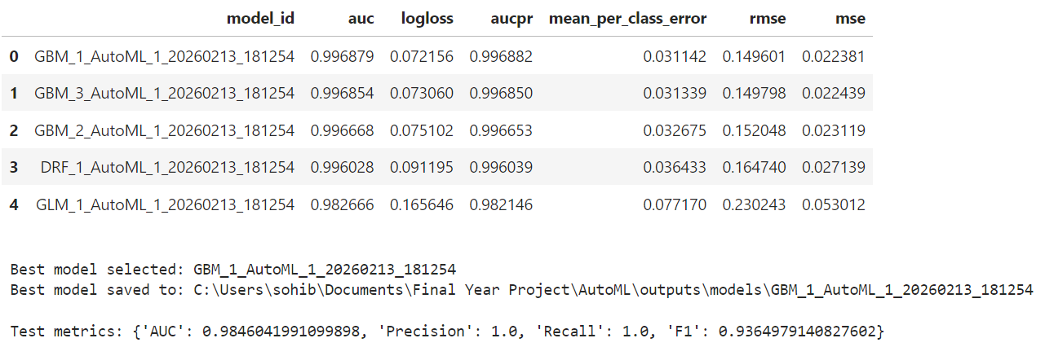
The leaderboard shows that GBM-based models consistently achieved the highest performance, indicating their suitability for anomaly detection tasks in the UNSW-NB15 dataset.

Appendix B – Additional Results and Supporting Figures
B.1 Model Performance Metrics
The final model performance was evaluated using standard classification metrics at the optimal F1 threshold. The results correspond to the best-performing AutoML model identified during experimentation.
{
"AUC": 0.9846,
"AUCPR": 0.9887,
"Best_F1_Threshold": 0.8752,
"Precision": 0.9578,
"Recall": 0.9161,
"F1": 0.9365,
"FPR": 0.0494,
"Best_Model": "GBM_1_AutoML_1_20260213_181254"
}
These results confirm the strong detection capability of the proposed feature-centric AutoML framework, achieving high precision and recall while maintaining a low false positive rate.

B.2 Experiment Configuration
The experimental configuration used to ensure reproducibility is summarised below:
{
"seed": 42,
"target": "label",
"leakage_columns_removed": ["id", "attack_cat"],
"train_shape": [175341, 45],
"test_shape": [82332, 45],
"X_train_shape": [175341, 42],
"X_test_shape": [82332, 42]
}
This configuration demonstrates the preprocessing steps, dataset structure, and feature preparation applied prior to model training.

B.3 Summary of Experimental Results
Table B.1 presents a summary of the final evaluation results across datasets, including performance and efficiency metrics.
Dataset | AUC | F1 | Precision | Recall | FPR | Row/sec | Energy (kWh)
UNSW-baseline | 0.9846 | 0.9365 | 0.9578 | 0.9161 | 0.0494 | 75080 | 0.000008
NSL-KDD | 0.9451 | 0.9065 | 0.8681 | 0.9484 | 0.1904 | 47878 | 0.000006
The results demonstrate that the proposed framework maintains strong detection performance across datasets while achieving high processing throughput and low estimated energy consumption.

Appendix C – Dataset Features Summary
C.1 ROC Curve Comparison (UNSW-NB15)
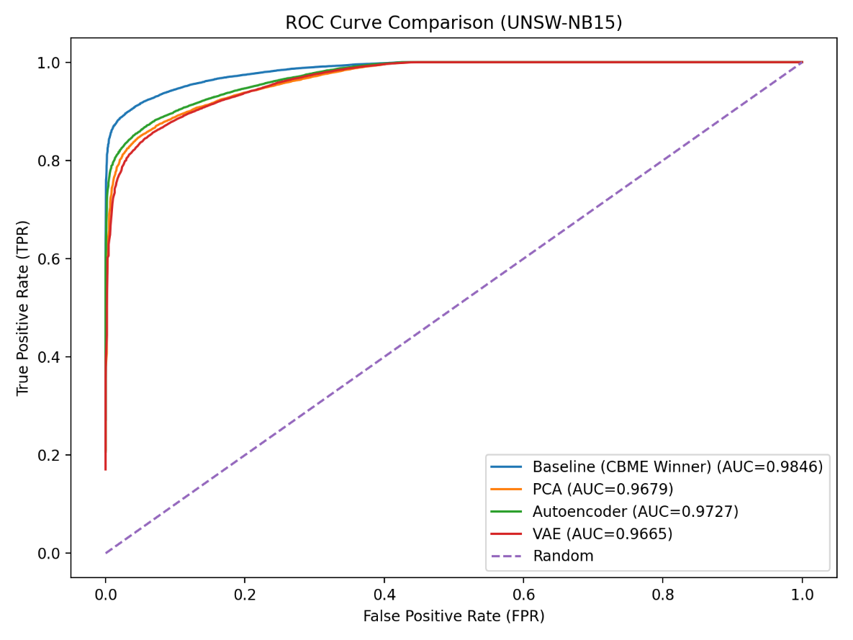
This figure compares the performance of different feature engineering approaches. The baseline feature selection method (CBME winner) achieves the highest AUC, demonstrating superior classification capability.

C.2 Confusion Matrix (UNSW Baseline Model)
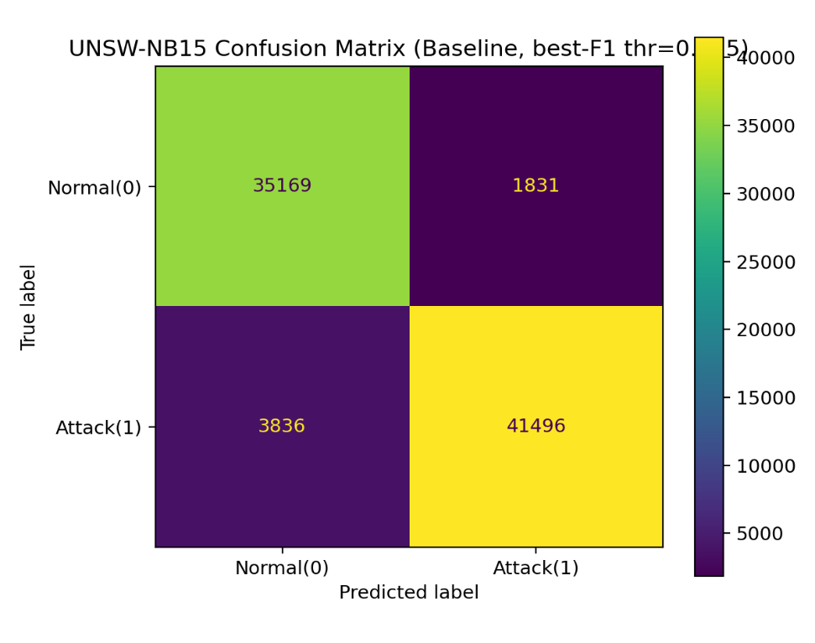
The confusion matrix illustrates classification performance, showing a high number of correctly detected attack instances and a relatively low number of false positives.

C.3 Feature Importance (SHAP Analysis)
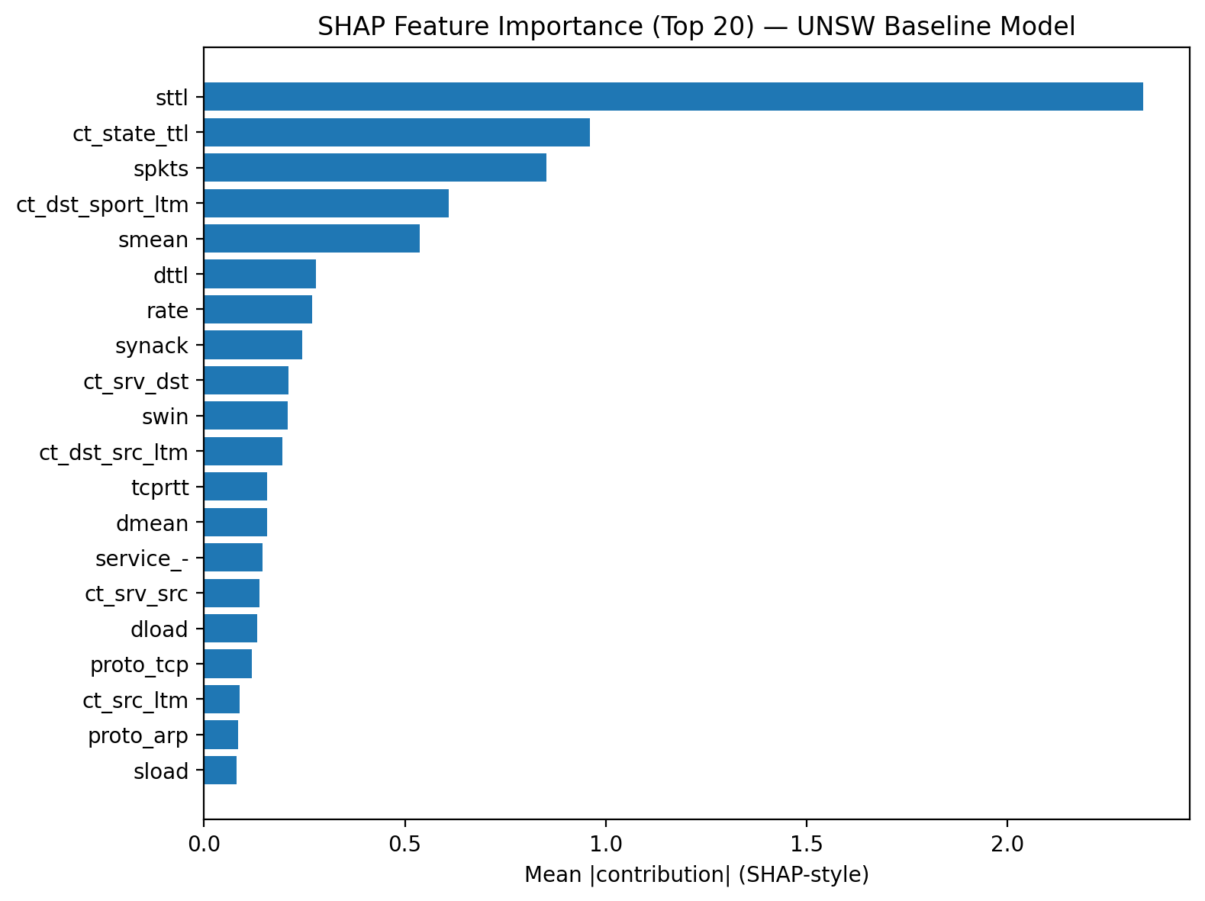The SHAP analysis highlights the most influential features contributing to model predictions. Features such as sttl, ct_state_ttl, and spkts have the highest impact, providing interpretability to the model.

C.4 Feature Engineering Method Comparison
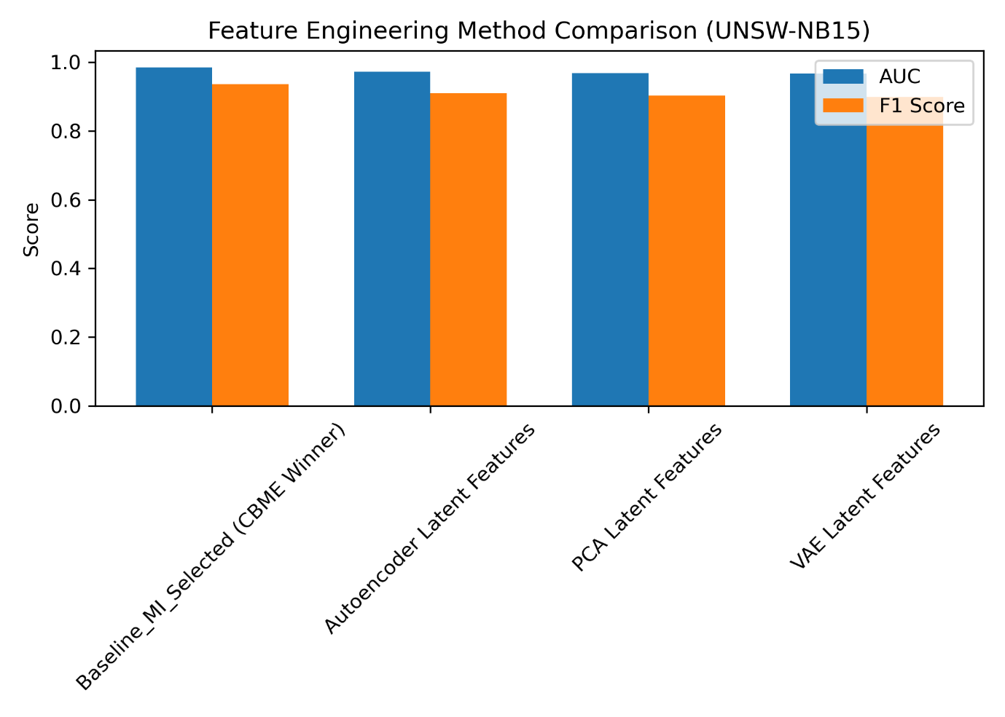
This figure compares different feature engineering strategies. The baseline approach outperforms latent feature methods (PCA, Autoencoder, VAE) in terms of AUC and F1 score.

